AGENDA
AS Council Meeting
Tuesday, March 10th, 2026, @ 4:40 pm in-person & Zoom
______________________________________________________________________________

CALENDAR LINK: AS 2025-2026 Mega-Calendar
Zoom Meeting Link
AS Consolidated Drive
AS EDIIA Inquiry Form

 | To note:  - Please skim over updates for the week prior to the meeting (no meeting last week)  - Remember to add discussion items (including sharing events, initiatives, etc…) to the agenda items  - Email me (tgill@qmed.ca) if you’re having trouble with this doc!  - I’m here to help :)

- Opening of the meeting
- Motion to start the meeting (2 people)
  - Tejas
  - Mary
- Motion to adopt agenda (2 people)
  - Tejas
  - Mary
- Approving last meeting’s minutes
- Question period
- Council Updates
  - AS President: Jeffrey Sun
  - Vice-President of External Affairs, Senior: Zoë Mohan
  - Vice-President of External Affairs, Junior: Tegvir Grewal
  - Vice-President of Internal Affairs Kingston: Bianca Marcella
  - Vice-President of Internal Affairs Lakeridge: Karanvir Singh
  - Vice-President of Academic Affairs: Kaamraan Islam
  - Academic Coordinator: Yasameen Ihsan
  - Vice-President of Finance: Chirag Chopra
  - Treasurer: Sabrina Smith
  - Communication Officer: Janet Lane
  - University Affairs Officer, Senior: Stephanie Fu
  - University Affairs Officer, Junior: Mary Arakelyan
  - Social Affairs Officer: Britney Feng
  - Athletics Officer: Nadine Abou-Seido, Carson Visser
  - Global Health Liaison, Senior: Arin Abraham
  - Global Health Liaison, Junior: Bahar Rafinejad
  - Student Initiatives and Research Officer: Shanzey Ali
  - SIGCO: Zarah Rahman
  - Wellness Officer: Jane Porter
  - Equity Officer, Senior: Tim Song
  - Equity Officer, Junior: Jocelyn Emmerson
  - Lakeridge Engagement Officer, Senior: Tasneem Patel
  - Lakeridge Engagement Officer, Junior: Basant Dhillon
  - Student Representative to the Admissions Committee Sr: Tate Erickson
  - Student Representative to the Admissions Committee Jr: Abby McEwan
  - First Year President - Kingston: Ekene Onyeka
  - First Year President - Lakeridge: Ryan Hunter
  - Second Year President - Kingston: Souzan Yacob
  - Second Year President – Lakeridge: Yousef Safar
  - Third Year Co-Presidents - Kingston: Jaskarn Dhaliwal, Akanksha Krishnan
  - Third Year President - Lakeridge: Liam Rautu
  - Fourth Year Co-Presidents: Henna Salim, Joshua Bierbrier
  - Speaker of Council/Chief Electoral Officer: Tejas Gill

- Agenda Items (30 mins)

  - Adding agenda items:
    - All agenda items MUST be large-scale topics warranting opinions/voting from a majority of AS members
    - Agenda items are first-come-first-serve
    - Add your agenda item below indicating:
      - Name
      - Your name
      - Your position
      - Maximum discussion time
      - A 2-sentence description
    - Example below:

  - Example:
  - Putting bunnies on the buses, presented by Tejas Gill (Speaker) - (5 mins)
    - Details: The bunnies are not on the buses, but we should put them back on the buses for the good of QMed. Require opinions from AS members and a vote.

  - Agenda item discussion:
    - Prior to each discussion item, the Speaker will take a list of max. 10 individuals to be on the Speakers List

  - AGENDA ITEMS (30 mins)
(Add your items below with your name + position)

March Senate Submission about OSAP - presented by Stephanie (Uni Affairs Sr) - 10 min
- Any opinions on these or additions to send to the Grad Student Senate Chair?
1. How does the university anticipate the changes in OSAP to affect students, especially those who fall within the category of not receiving financial support from one’s family but not qualifying for OSAP due to family earnings and those from low-income background? Is there any predictive data based on current student numbers that can show the extent to which students will be affected with the changes in OSAP?
2. For needs-based financial aid, what kind of factors is the university considering to determine whether a student qualifies or not? Are material costs, cost of living considered, etc. basically costs outside of tuition taken into consideration when looking at applications? Will financial aid be strengthened to offset the changes in OSAP to allow students to continue to attend university?
3. The Student Access Guarantee (SAG) is still open for negotiations with the government. Will students be consulted when deciding on strategies for negotiations? If so, what does the timeline look like and how would these consultations occur?
- Discussion:
  - Additional question: how these changes will affect graduate students (since our tuition is higher)
  - We can send out a google form to the classes to capture any questions from students to add as well
    - Stephanie will check if there is time to send out a google form before the meeting
    - Stephanie made a google form and will send it to the classes to gather feedback

SGPS Suggestions on Policy Changes Re: Filling Vacant Positions – presented by Jeff (AS President) - 15 min
- Ideas on changes
- Currently there is only a policy for students who are expelled. This policy says to just elect a new senior and junior executive - Tejas will double check this.

SGPS Council Representatives – presented by Jeff (AS President) - 10 min
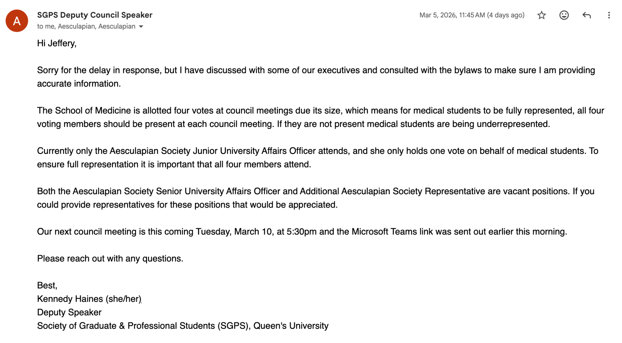

Discussion:
- the situation is that we are only sending one student and we need to fill 4 seats (University affairs junior, University affairs junior, AS President, and we need one more student)
- Commitment is once a month on Tuesday at 5:30 for about 2 hours
  - this often coincides with these meetings
- Are we being underrepresented? - there is not much that comes up that affects med
  - Maybe the junior can take a look at the agenda ahead of time to decide if we should have 4 people there to vote/voice concerns
  - We don't want to send more people if we don't have to because we are all busy

  - UPDATES/EVENTS/INITIATIVES (5-10 mins)
(Add your event below with your name + position)

Student awards nomination committee, presented by Bianca (VP Internal) - 5 minutes
- The committee shall include all the executive members of the AS (President, VP Internal, VP External, VP Academic, and VP Finance), Equity Officer Sr., University Affairs Sr. and two general members of the student body.
- Also wondering how to include Lakeridge in the student awards or if they have their own student awards
- Discussion:
  - Lakeridge can be on the committee as well

AEPs on the AS website, presented by Sabrina (Treasurer) - 30 seconds
- Wondering if we can remove inactive AEPs on the AS website, a couple people have been asking if they exist, which I don’t think most of them do

- Next meeting: March 24, 2026
- Motion to end meeting (2 people)
  - Zarah
  - Jeff

