Trainee Psychological, Physical, Cultural and Professional Safety Guidelines.
Program Name:

Document Type | Program Specific template: Trainee Psychological, Physical, Cultural and Professional Safety guidelines
Date Approved | December 6th, 2024
Approved By | PGMEC, SOMAC, Faculty Board
Date | December 6th, 2024
Review to Commence | December, 2027
Responsible Portfolio/Unit/Committee | Postgraduate Medical Education
Responsible Officer(s) | Associate Dean, PGME
Relevant Policies, Legislation, Accreditation Documentation | General Standards of Accreditation for Institutions with Residency Programs  General Standards of Accreditation for Residency Programs  PARO-OTH Collective Agreement  COU Emergency Preparedness Guidelines  PGME Leaves of Absence and Return to Training Policy  PGME Fatigue Risk Management Policy  Professional Responsibilities in Medical Education (CPSO Supervision Policy)  Queen’s University Harassment and Discrimination Prevention and Response Policy  PGME Resident Harassment and Discrimination Investigation Procedure  Policy on Sexual Misconduct and Sexual Violence Involving Students  Occupational Health and Safety Act, R.S.O 1990, C.0.1  Kingston Health Sciences Centre Health and Safety Review

- BACKGROUND

It is expected that programs will augment the central PGME Safety policy with program specific policies addressing the unique the learning and working environments within each program.

Postgraduate Medical Education residents and fellows (“trainees”) have the right to a healthy and safe learning environment during their training. A healthy and safe learning environment includes four key concepts: physical, psychological, cultural and professional safety. The responsibility for promoting and monitoring for a culture and environment of safety for trainees rests with the School of Medicine Postgraduate Medical Education Office (PGME), the program, the employer (KHSC or sponsors), sites, affiliated clinical training sites faculty and staff, and trainees themselves.

Trainees have dual roles as learners within the University and as clinical service providers. Trainees are either employees Health Sciences Centre (KHSC) or sponsored by external funders or departments. Trainees learn and work in a variety of settings within their local home program environment and across a well-established regional network of learning sites. As such, there are a combination of policies and procedures that inform how trainee safety is managed.

Complementary and Legislative Standards, Policies and Guiding Documents
The PGME Trainee Safety Policy has been developed based on the standards and principles as outlined in the General Standards of Accreditation for Institutions with Residency Programs and the General Standards of Accreditation for Residency Programs, the Professional Association of Residents of Ontario (PARO) and the Ontario Teaching Hospitals (OTH) Collective Agreement, the Occupational Health and Safety Act (OHSA), and Queen’s University governing policies (e.g., Environmental Health and Safety, Queen’s Policy Statement on Health and Safety).

Definitions
* The following ‘safety’ definitions are adapted from the General Standards of Accreditation for Residency Programs (version 3.0), with added detail for the purpose of this policy. They will be reviewed peridocially to align with updates.

Cultural Safety: Cultural safety is an outcome based on respectful engagement that recognizes and strives to address power imbalances, institutional discrimination, colonization and colonial relationships as they apply to healthcare and health education, so that the providers can work to dismantle the inherent hierarchy (e.g., hierarchy based on socially identified elements). Culturally safe practices require critical thinking and self reflection about inherent power privilege and racism in educational and clinical settings. It goes beyond cultural competence (e.g., in improving indigenous health) and results in an environment free of racism and discrimination where people feel safe learning and working in an environment and when receiving healthcare.

Fatigue Risk Management: A set of ongoing fatigue prevention beliefs, practices, and procedures integrated through all levels of an organization to monitor, assess, and minimize the effects of fatigue and associated risks for the health and safety of healthcare personnel and the patient population they serve.

Physical Safety: Is safety against physical harm. It includes but is not limited to protection against biological risks such as immunization, radiation protection, respiratory protection, exposure to body fluids; it also includes protection against risks associated with physical spaces, with care provided during home visits, travel, and meetings with violent patients.

Professional Safety: Is safety against threats to professional status. It includes but is not limited to fair and transparent academic processes (e.g., equitable opportunities, fair assessment practices), protections from, and support in the setting of, allegations of malpractice, disclosure assistance, academic and professional record confidentiality, as well as reporting procedures where confidentiality is assured and there are no reprisals to anyone reporting in good faith

Psychological Safety: Is safety from threats to psychological wellbeing. It includes but is not limited to prevention and protection of trainees’ psychological safety. It also includes access to resources to counter the risks of psychological distress, intimidation and harassment, as well as access to educational supports to address situations causing impairment (e.g., fatigue, stress, alcohol or substance use). For greater clarity, psychological safety provides opportunities for interpersonal risk taking and that trainees will not be subject to ridicule or humiliation for asking questions, making suggestions, or identifying mistakes.
- Scope

The Program Name Safety Policy applies to both residents and clinical fellows, collectively referred to as “trainees” working in an affiliated teaching site, academic center, community clinic or on placement.

- Purpose

- To augment the PGME Safety Policy by identifying specific provisions to address safety concerns related to educational activities undertaken as part of the _________NAME OF_____ training program.

- To describe the mechanisms in place at the program level for addressing, reporting, and/or reducing unsafe events and conditions: list them here

- To establish that trainees have the right to use their judgment when deciding if, when, where, and how to engage in clinical and/or educational experiences that they perceive to involve safety risks and to report any concerns that have not been addressed adequately.

- To define and articulate to trainees what is meant by psychological, physical, cultural and professional safety.

RESPONSIBILITIES

The program will:
- Identify and communicate foreseeable safety risks related to psychological, physical, cultural and professional safety within the program.
- Educate trainees about risk minimization strategies
- Provide educational experiences that take into account, among other things, the educational benefit relative to any safety risk.
- Create guidelines and procedures to support psychological, physical, cultural and professional safety.
- Create an internal reporting mechanism for trainees to report on issues related to their psychological, cultural, physical and professional safety within the home program and at off-site locations. Reports of, and response to, all manner of incidents related to Environmental Health, Occupational Health, and Personal Health and Safety will be addressed as outlined in the PGME Safety Policy.
- Acknowledge, endorse and adhere to the PGME Safety Policy.
- React promptly to address safety and wellness concerns. (see Appendix A)
- Report all safety concerns/incidents, actions taken, and outcomes when relevant, to the PGME Office (Reporting Form).
- Protect trainees from any negative impact or reprisal as a result of reporting a safety concern.
- Ensure trainees are not negatively impacted for refusing to engage in clinical or educational experiences if they feel at risk in doing so. It is recognized that there are times (e.g. in outbreaks of infectious diseases), when a residual risk will remain after all known precautions are taken. Professional responsibility to patients may require engaging in patient care despite these risks.
- Provide a rotation/alternate learning experience site-specific orientation for trainees, and ensure they are made aware of relevant safety policies before beginning clinical duties. Site-specific orientations may be delegated to a site supervisor, placement coordinator, or other as identified by the learning site.
- Promote a culture in which trainees are encouraged, and feel supported, to report and discuss safety concerns involving all aspects of trainees’ safety including articulating mechanisms to report breaches of cultural, psychological, professional, and physical safety without fear of reprisal.
- Review the PGME policy with their Residency Program Committee for relevance to the training environment of the program. Program-specific policies cannot conflict with the PGME Trainee Safety Policy, the Queen’s University Harassment and Discrimination Prevention Policy and/or the Sexual Violence Policy.

The trainee will:
- Participate in workplace safety training and orientation sessions as required by employer, PGME, the program and clinical teaching site(s).
- Comply with workplace safety policies and procedures including use of personal protective equipment and radiation protective garments.
  - Report injuries within 24 hours to the appropriate Occupational Health and Safety or via Queen’s Environmental Health and Safety. (See Appendix C, PGME Safety Policy)
- Be up-to-date on required immunizations.
- Communicate any safety concerns for themselves, colleagues, or patients to their supervisor, program, hospital administrator, PARO, PGME Wellness Office, Queen’s University Human Rights and Equity Office, or the PGME Office.
- Exercise judgement and apply critical thinking skills with respect to evaluating all workplace safety risks.
- Recognize and request support from their program or immediate supervisor when they are impaired (e.g. fatigued, emotionally stressed, or impaired for any other reason to the point that it would reasonably be expected to impact personal, patient and/or other’s safety. (See also Fatigue Risk Management Policy)
- Adhere to the relevant health and safety policies and procedures of their current teaching site.
- Immediately notify their supervisor, clinical administrator, or senior trainee (or more senior person) of perceived safety concerns
- Contact PARO, or other Wellness Supports, if there has been a safety issue and support is required.
- Contact their Program Director, the Associate Dean, PGME or the PGME Wellness Office, if involved in a safety-related event, or have concerns about their safety in the learning environment.
- Use their best judgment when deciding if, when, where, and how to engage in clinical and/or educational experiences:
  - At times, a trainee may be called upon to respond to an acute situation involving a patient which poses a risk to the trainee’s personal safety and wellbeing. Trainees are expected to consider the effect on themselves and the patient when deciding on a course of action.
  - Every effort should be made to consult more experienced health care providers or staff and seek assistance, support or alternative courses of action.
- Report to the site supervisor immediately, and to the program director (or delegate) at the earliest reasonable time, if they don’t feel they can proceed continue work because of a safety concern.
- Requests for accommodation should be in accordance with the Accommodations Policy and follow the appropriate procedures. (link to policy)

The hospital site/affiliated clinic and/or community teaching practice will:
- All affiliated teaching sites as well as ambulatory, outpatient and private practice locales are accountable for the environmental, occupational, and personal health and safety of the trainees engaged in the provision of clinical care.
- All teaching sites must provide an orientation to the learning and working environment including information relevant to occupational health.
- All teaching sites must meet the requirements of the PARO-OTH Collective Agreement.All teaching sites will share the reporting mechanism and process for workplace injuriesProcedures
- The training program requires residents to engage in the following specific situations that may pose a safety risk: (**select or add as necessary**)
•house calls
•work in isolated or poorly protected environments
•exposure to potentially dangerous environments
•exposure to potentially harmful bodyfluids
•exposure to environmental hazards
•encounters with potentially violent or aggressive patients
•exposures to potentially dangerous equipment and/or high-risk transportation
- The program commits to providing trainees with a full disclosure of foreseeable potential risks associated with these situations.
- The program will ensure that trainees receive education and preparation for these activities using best available evidence and practices and assess trainees as deemed appropriate understanding prior to involvement in these activities.Trainees will not be required to see patients alone in any of the above situations if not appropriately supervised
- A trainee should not encounter negative repercussions for decisions they made in good faith related to personal safety concerns.
- The Program Committee, or delegated committee, will review all concerns brought forth and take steps to minimize future risk.
- Programs are proactive in fostering an environment that allows for trainees to identify cultural, physical, professional and psychological safety concerns.
- Where a trainee reports a concern, they are supported in reporting and are not subject to reprisal, intimidation or harassment.
- Programs will identify opportunities to conduct continuous quality improvement relying on qualitative and quantitative data gathered through the program reporting mechanisms.
- There are opportunities to debrief critical incidents and adverse events within the program fostering collegial sharing of information and providing support to trainees.
- Where a trainee repeatedly fails to engage in an activity that can be reasonably considered part of their scope of practice, that is a mandated component of the training, and for which all means of risk reduction and education have been instituted by the program, the program committee, or delegate, will review the circumstances and determine if a modified learning plan or other outcome as identified in the Assessment, Promotion and Appeals Policy (APA) would be required. Any appeal of this decision would follow the Appeal Process outlined in the APA.
- Where a trainee has identified a need for accommodation, the Program is required to support the trainee and address accommodation requests as outlined in the Accommodations Policy (add link).

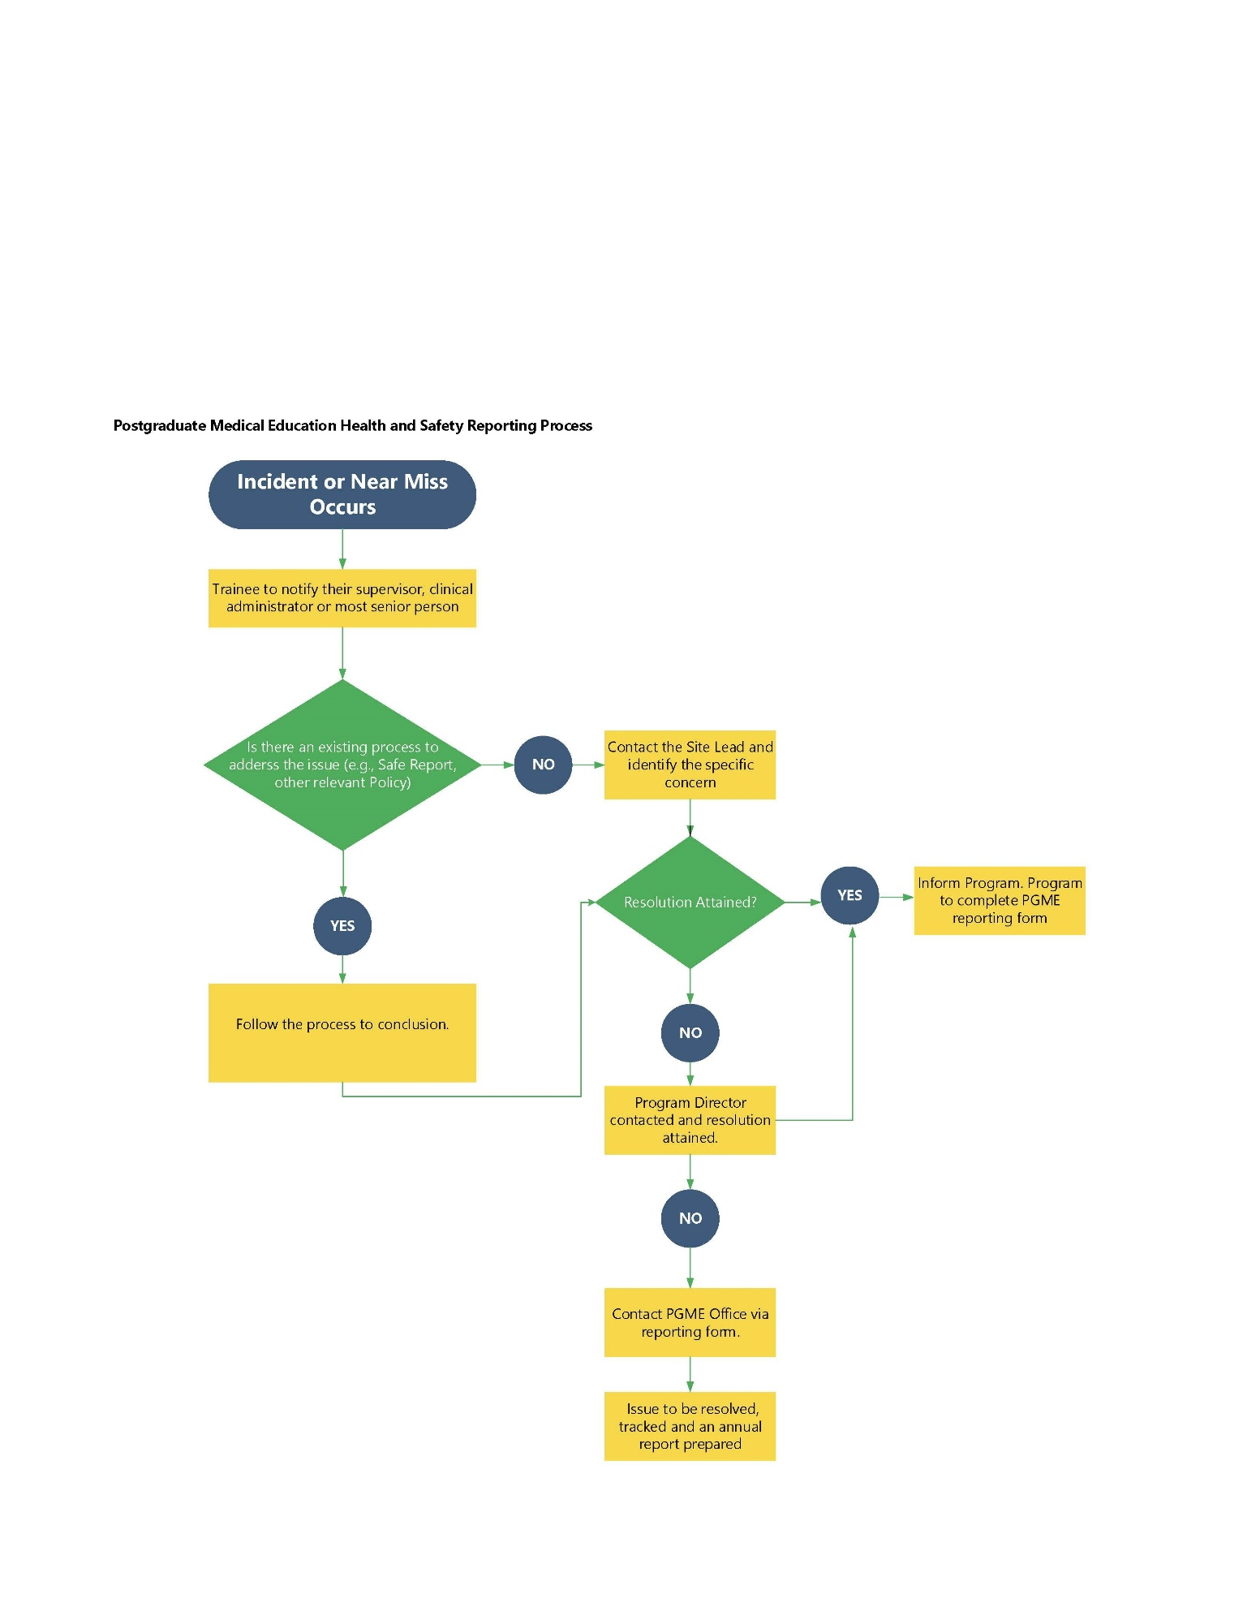
Appendix A- Health and Safety Policy Reporting

The Program is responsible for completing the reporting form

CanEra Glossary of Terms: General Standards of Accreditation for Residency Programs (version 3.0)
Amy Edmondson, The Fearless Organization

