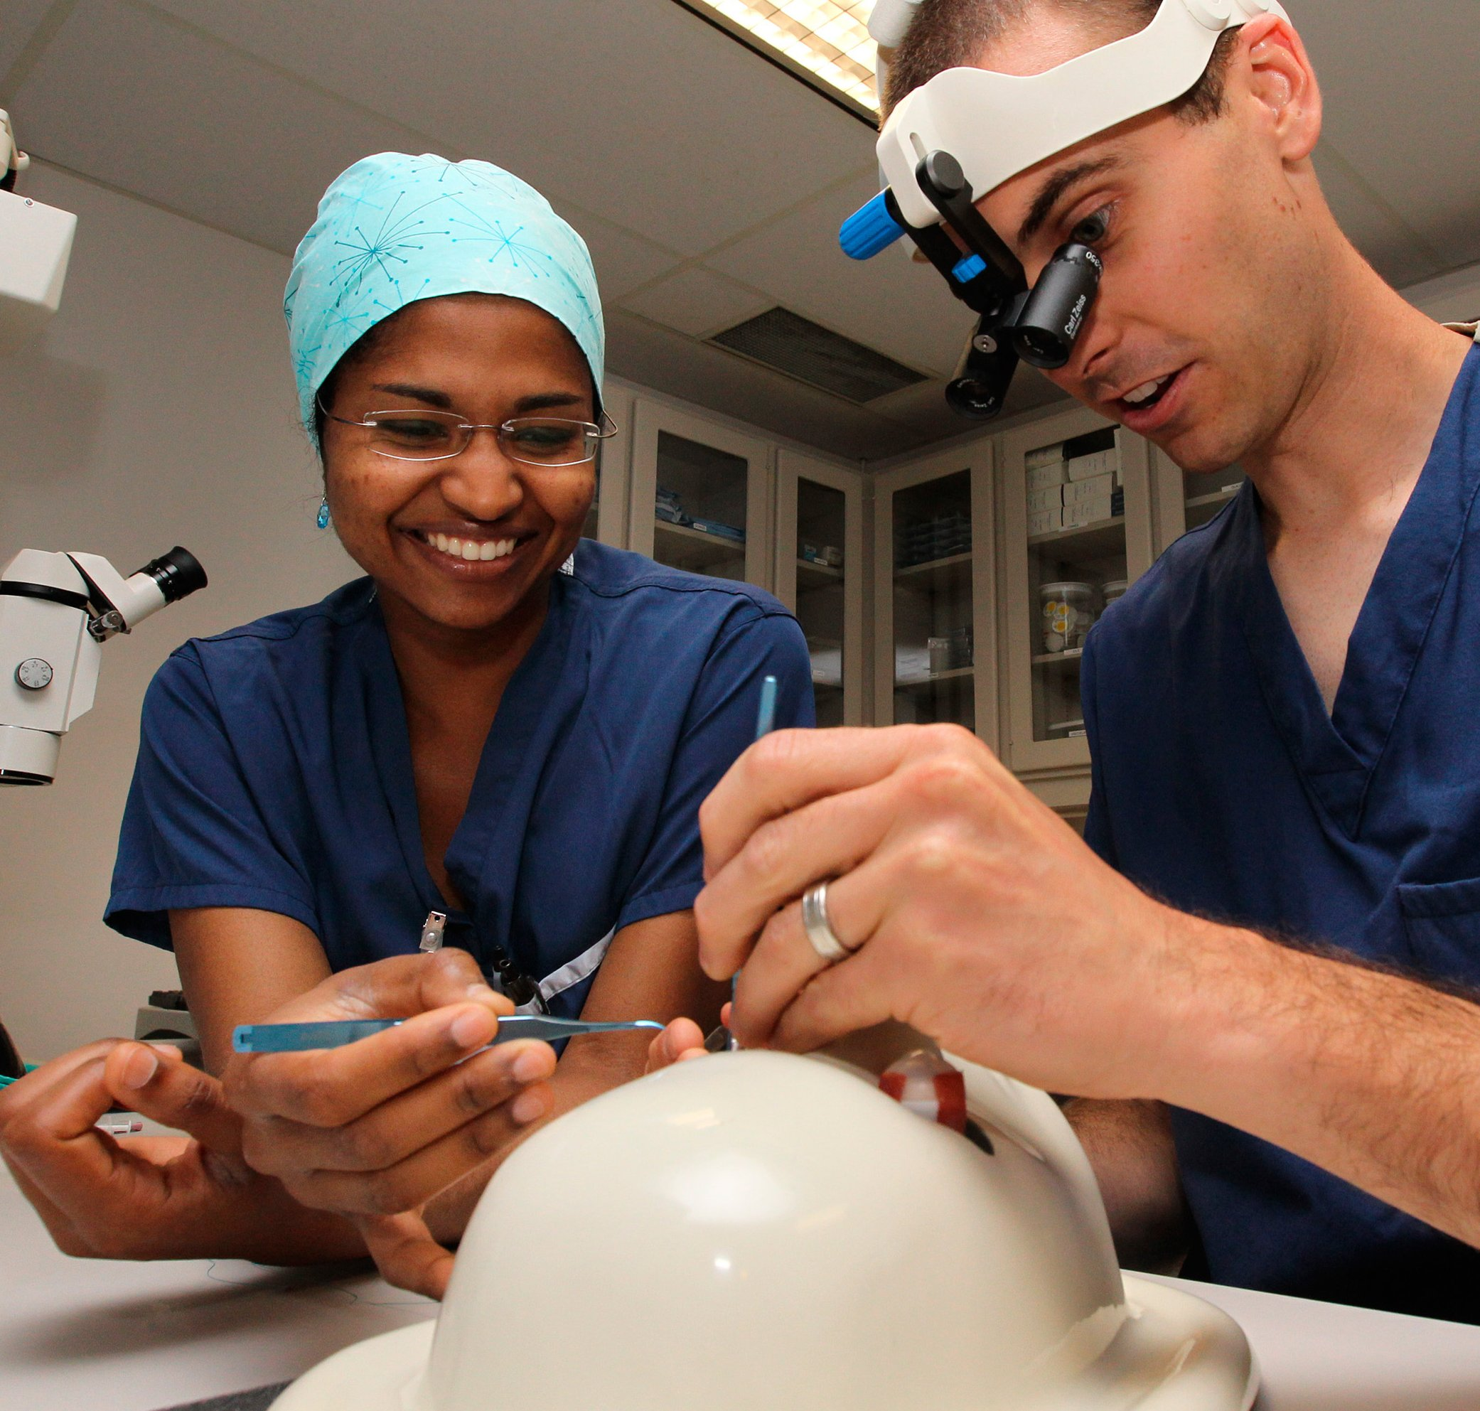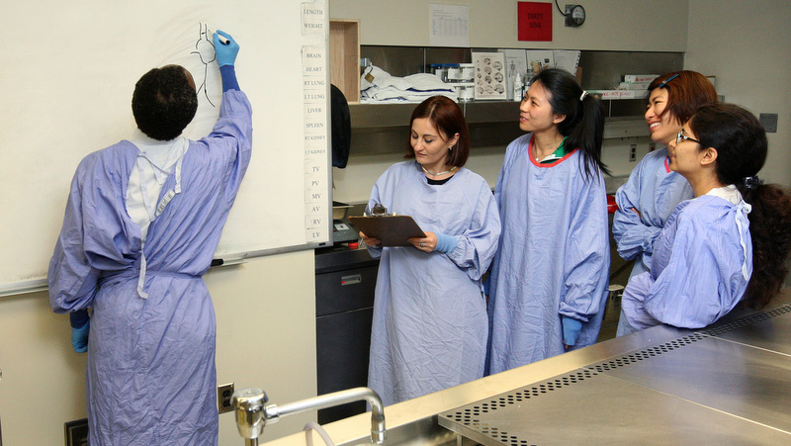

Thursday, March 23, 2017 Donald Gordon Centre

Chief and Senior Resident Workshop

A senior resident physician who acts temporarily as the administrative director of the house staff in a postgraduate program. There may be an associated clinical responsibility with the position. The period of duty varies, depending on the size of the program, the length of the residency, and the number of house staff members.

# Chief Resident

G. Ross Walker, MD, FRCSC, FACS

Associate Dean, Postgraduate Medical Education

Congratulations on becoming the new chief and senior resident for your program. This appointment will be a rich opportunity for both personal and professional growth.

Through the course of this workshop, you will learn valuable management and leadership skills to support your additional responsibilities. Each session has been purposely selected to highlight a unique aspect of your chief and senior role.

I hope you find the day to be informative, and wish you much success in the year ahead.

### About the Workshop

|  |  |  |
| --- | --- | --- |
| TIME | TOPIC | SPEAKER |
| **12:00 pm – 12:30 pm** | **REGISTRATION & LUNCH** | |
| **12:30 pm – 1:30 pm** | Leadership and Being a  Chief Medical Resident | Dr. Dan Howes  Emergency Medicine |
| **1:30 pm – 2:30 pm** | Managing Conflict | Dr. John Drover  Chair, Critical Care Program |
| **2:30 pm – 2:45 pm** | **BREAK** | |
| **2:45 pm – 3:15 pm** | Hospital Roles and Responsibilities | Chris Gillies  Director of Medical Affairs,  KGH and HDH |
| **3:15 pm – 3:45 pm** | CBME and the Chief Resident Responsibilities | Dr. Jena Hall, PGY 2, CIP/OBGYN  Dr. Samantha Buttemer,  PGY 2, PH&PM |
| **3:45 pm – 4:30 pm** | PARO | Dr. Bryce Durafourt,  PGY 2, Neurology  Dr. Miriam Lermer  PARO Board Member, McMaster |
|  |  | |

### Program Schedule

Workshop material is available online at: meds.queensu.ca/postgraduate/educational_sessions

PARO

1.877.979.1183

paro@paroteam.ca

### NOTES

KGH People Services and Organizational Effectiveness

613.548.2365

peopleservices@kgh.kari.net

Dr. Melissa Andrew

Director of Resident Affairs

613.533.6000 x78451

andrewm@queensu.ca

Postgraduate Medical Education

613.533.2543

pgme@queensu.ca

# Aenean eget urna