Lumbar Puncture
A Self-Directed Learning Module
Technical Skills Program
Queen’s University
Department of Emergency Medicine
Introduction
Lumbar puncture (LP) and analysis of cerebrospinal fluid (CSF) has been part of the medical profession for over one hundred years. This relatively simple procedure is widely employed, yet a surprising number of physicians are poorly educated in regards to when and how this procedure is performed. The goal of the this educational module is to familiarize the student physician on the theory behind the lumbar puncture as a diagnostic tool and to guide the student through the steps involved in performing a safe and successful lumbar puncture for the adult patient. Students should complete this module and complete the embedded multiple-choice questions prior to their scheduled lumbar puncture seminar. There will be a brief multiple-choice exam based on this material at the beginning of the seminar.
Objectives
By the completion of this teaching unit, the student physician will be able to:
- List the indications for lumbar puncture
- List the contraindications for lumbar puncture
- Describe when a CT scan is and is not required prior to lumbar puncture
- List and discuss the complications of lumbar puncture
- Describe the equipment employed for lumbar puncture
- Demonstrate a safe method for performing a lumbar puncture on a model
- Discuss the appropriate CSF studies to be ordered in cases of suspected meningitis or subarachnoid hemorrhage
Indications
The indications for lumbar puncture include (common uses in bold):
- Diagnosis of central nervous system (CNS) infection
- Diagnosis of subarachnoid hemorrhage (SAH)
- Infusion of anesthetic, chemotherapy, or contrast agents into the spinal canal
- Treatment of idiopathic intracranial hypertension
- Evaluation and diagnosis of demyelinating or inflammatory CNS processes
Perhaps the most common indication for LP is to evaluate the patient for CNS infection. CSF samples are needed for the diagnosis of bacterial and viral meningitis as well as for numerous other infective processes such as CNS syphilis and other encephalopathies. The CSF may be examined for signs of infection by studying it for microbes, cells and culturing the CSF for organisms.
The diagnosis of subarachnoid hemorrhage is the other emergent indication for LP. In SAH, blood seeps into the CSF and can be detected by lumbar puncture. In this day and age, CT scan is often used to diagnose SAH, but LP is used when a CT scan may have missed the diagnosis of SAH. CT scan may miss small bleeds or bleeds which occurred greater than twelve hours prior to CT scan. In these instances, LP proves to be instrumental in the diagnosis or exclusion of SAH.
Other common indications for LP include spinal anesthesia for procedures and operations as well as injection for contrast agents into the spinal column for imaging such as in CT – myelography. CNS chemotherapy is often delivered after lumbar puncture. Other uses of LP include evaluation of inflammatory CNS processes such as multiple sclerosis.
Contraindications
As with any procedure, there are times when it is not safe to proceed with lumbar puncture. These contraindications are:
- Skin infection near the site of the lumbar puncture
- Suspicion of increased intracranial pressure due to a cerebral mass
- Uncorrected coagulopathy
- Acute spinal cord trauma
The presence of skin infection near the site of the LP increases the risk of carrying the infection into the CSF with the LP needle. Thus, infection at the potential LP site is a contraindication to performing a lumbar puncture at that area.
Perhaps the more worrisome contraindication to lumbar puncture is the suspicion of increased intracranial pressure (ICP) due to a cerebral mass lesion. In the presence of a potential brain tumor, cerebral hemorrhage, cavernous sinus thrombosis, brain abscesses, epidural or subdural hematomas , patients are at increased risk of deteriorating neurologically with LP. As the space-occupying lesion grows, ICP rises. When lumbar puncture is performed in these patients, a low-pressure shunt is formed at the site of LP where CSF can escape. As the CSF pressure drops in the spinal column, CSF and brain mass may then shift towards the low-pressure outlet (the LP site). This may lead to either trans-tentorial or uncal herniation and acute neurological deterioration. Patients with increased ICP from mass lesions often display decreased levels of consciousness, focal neurological signs or papilledema on physical exam. Any of these findings make lumbar puncture contraindicated until further evaluation can be undertaken. The next section "To CT or Not to CT", addresses the issue of when imaging is required prior to LP.
As with most invasive procedures, uncorrected coagulopathy is a contraindication to LP. This includes those on heparin, coumadin, or with clotting defects such as disseminated intravascular coagulation, hemophilia or thrombocytopenia. Having said that, when these clotting abnormalities are corrected, lumbar puncture is no longer contraindicated. Reversal of coumadin with Vitamin K or fresh frozen plasma, replacement of a hemophiliac's clotting factors or transfusion of platelets to the thrombocytopenic patient would all allow for safe lumbar puncture.
In the presence of acute spinal trauma, LP is understandably contraindicated as both the bony anatomy and spinal structure may be altered and not allow for safe placement of the LP needle.
To CT or not to CT? That is the question.
As discussed, the suspicion of increased ICP due to a mass lesion is a contraindication to lumbar puncture. In these cases, a CT scan is recommended prior to LP. Unfortunately, it has been wrongly interpreted by many that all patients require CT scan prior to their LP.
The clinical findings of decreased level of consciousness, focal neurological deficits, or papilledema make CT scan necessary prior to LP. Any of these findings place a patient into a high-risk group for having increased ICP. Having said this, LP's performed on these patients do not always lead to disaster. Studies reviewing LP in patients with known brain neoplasms, hematomas or abscesses found that neurological deterioration with LP occurs in only 0 - 5% of patients. This low rate occurs in patients known to have signs, symptoms and diagnoses of increased ICP with mass lesions!
Given this low complication rate, it has been accepted that patients with a normal level of consciousness, lack of focal neurological findings and absence of papilledema are safe to undergo LP. Many clinicians ask, "What if I cannot reliably see the fundi of my patient?". Papilledema is a late finding of increased ICP and is present in less than half of those with raised ICP. If your patient has a normal level of consciousness, no focal neurological defects, and you cannot visualize the fundi, it is still safe to proceed with the LP.
The safety of this practice has been studied in suspected meningitis. In 1993, the Canadian Medical Association Journal reviewed the need for CT prior to LP in meningitis and found that there were no clinical studies nor anecdotal reports of patients with suspected meningitis and normal neurological exam deteriorating with LP. In 1993, Durando et al reviewed almost 450 LP's in adult patients in suspected meningitis. They found that 5 cases had neurological deterioration after LP, and all these patients had either signs of increased ICP or focal neurological deficits prior to LP. In suspected meningitis, patients with a normal level of consciousness, no focal deficits and an absence of papilledema (or inability to visualize the fundi) should undergo lumbar puncture without prior CT scan. If the clinician finds reason to image the patient prior to LP, and meningitis is suspected, the patient must receive antibiotics prior to CT scan.
Delays in starting appropriate antibiotic therapy, to arrange a scan can result in increased morbidity in the setting of bacterial meningitis. Arranging, performing and interpreting a CT scan will take a minimum of an hour in most cases even if the CT is up and running. If the technician and the radiologist need to come in from home, or the patient requires transfer to another center, it will involve a considerably longer period of time. It is worth repeating that these patients must get antibiotics prior to CT scan!
The safety of LP in suspected SAH is somewhat less clear. As mentioned earlier, large intracranial bleeds have the potential to increase ICP. Patients with large bleeds either die, have decreased levels of consciousness or neurological deficits. Patients with small SAH's often have more subtle presentations. These patients may not have neurological defects. Using the same logic as in meningitis, it is inferred that lumbar puncture is safe in the suspected SAH patient who has a normal level of consciousness, no focal deficits, nor papilledema. Unfortunately, this has neither been proven nor disproven by rigorous studies.
Complications
Associated with the contraindications for LP, are the complications of LP. The potential complications of this procedure are:
- Post LP headache
- Post LP back pain
- Seeding of infection to the CSF
- Epidermoid tumor implantation
- Uncal or transtentorial herniation and neurological deterioration
- Spinal hematoma
Post lumbar puncture headache is the most common complication of LP. The post LP headache develops in 5 – 40% of patients undergoing lumbar puncture. It is a headache that begins within 72 hours of LP and usually lasts less than 5 days. The headache is a bilateral pressure or throbbing that is intensified in the upright position and with coughing. The headache resolves when the patient is supine. The longer the patient is upright, the longer before it resolves when the patient is supine.
From a pathophysiological viewpoint, the post LP headache occurs because of the tear in the dura mater caused by the LP needle. This opening allows for the continued leakage of CSF out of the dura and this lower pressure allows the brain to shift downward. Traction on the pain sensitive bridging vessels, dura and nerves causes the headache. When supine, the pressure column of the CSF is equal and thus there is no pull on pressure sensitive structures of the brain and the headache resolves.
There are a number of ways to minimize post LP headaches in your patient. The first is to use the smallest size spinal needle possible. The smaller the needle, the smaller the tear in the dural fibres and the lower the incidence of post lumbar puncture headache. The incidence of post LP headache is about 70% with 16 – 19 gauge needles, 20 – 40% with 20 –22 gauge needles and 5 – 12% with 24 – 27 gauge needles. The LP kit carried in our hospital contains a 20 gauge needle. This module will teach you not only how to use the provided needle, but also how to utilize smaller spinal needles for LP.
Another factor that can be utilized to minimize the chance of post LP headache is the use of a stylet in the needle. This internal stylet prevents the needle from "coring" through the tissues while placing the LP needle. It is intuitive to use the stylet to prevent the needle from being blocked up with soft tissue while doing the LP. What is of interest, though, is that the replacement of the stylet into the needle prior to the needle's removal (at the end of the procedure) has been shown to reduce the incidence of post LP headache by 50%. It is theorized that during CSF collection, a strand of arachnoid fiber may enter the needle and when the needle is withdrawn the arachnoid strand is pulled out through the dural defect and produces and prolonged CSF leak. Replacement of the stylet prior to the LP needle's removal would prevent this.
Furthermore, the type of needle and the orientation of the needle's cutting edge also influence the incidence of post lumbar puncture headache. There are three main types of needles, pictured below. The Quincke needle was the first invented and has a beveled cutting tip. The Whitacre and Sprotte are "atraumatic" or pencil point needles and have blunt tips with lateral ports for CSF collection.
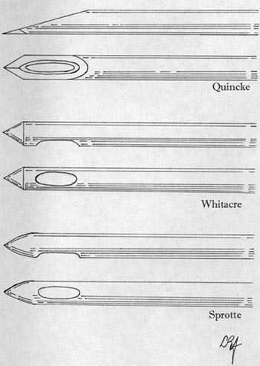
Figure 1. Spinal needle types
When using the Quincke needle, the orientation of the bevel influences the incidence of post lumbar puncture headache. Post LP headache is reduced by 50% or greater when the bevel is parallel to the dural fibres' long axis. To you and me this means that if the patient is lying in the lateral decubitus position, the flat portion of the bevel should point up towards the ceiling. An easy way to remember this is that when performing the LP in the lateral position, the bead on the plastic end of the stylet and therefore the notch that the stylet fits into should be pointing up at the ceiling.
Although the usual LP kit contains a Quincke needle, there is very good evidence that the atraumatic needles significantly reduce the incidence of post lumbar puncture headache. It is theorized that these needles spread the dural fibres and cut fewer fibres. This reduces the size of the hole in the dura and reduces the tendency to develop CSF leak. Numerous studies demonstrate post lumbar puncture headache rates of only 2-6% using atraumatic needles compared to rates of 18-40% using the same sized Quincke needles. Numerous direct comparisons have borne out the superiority of using atraumatic needles for reducing post LP headache.
There is considerable conflicting literature about a variety of other methods of reducing post lumbar puncture headache. Some recommend lying flat on one's back for 4 hours, some recommend lying prone and a few recommend activity right after lumbar puncture. To date, there are no post procedural interventions that seem to influence the incidence of post LP headache.
Therefore, in order to reduce post lumbar puncture headache, we recommend using small, atraumatic LP needles when doing lumbar puncture. In this module we will demonstrate the use of both types of needles, as some practitioners may not have access to small atraumatic spinal needles.
Also common after lumbar puncture is local back pain at the site of puncture. Approximately one third of patients will experience some local back discomfort after the procedure, which lasts for a couple of days. This is due to local soft tissue trauma. In rare cases, if the needle is inserted beyond the subarachnoid space, the annulus fibrosis may be damaged and the intervertebral disk can herniate. This is very rare, though.
Thankfully, other complications from lumbar puncture are much less common. The risk of introducing organisms into the CSF from a properly performed lumbar puncture is exceedingly small. This can occur with breaks in sterile technique, use of contaminated equipment and placement of the needle through infected skin. It is estimated that the incidence of such infection after lumbar puncture is about 0.2%.
Epidermoid tumor implantation is a theoretical concern that is very rare to see. The true incidence is unknown, but thought to occur when a plug of skin is carried into the spinal canal where it presents months to years later as an expanding epidermoid tumor. The use of a stylet with lumbar puncture has made this complication mostly one of historical significance.
Spinal subdural hematoma is also a rare complication reported in lumbar puncture. It is most common in those who undergo lumbar puncture while having coagulation abnormalities, including thrombocytopenia, anticoagulation and bleeding disorders. In spinal subdural hematomas, patients present with severe low back, radicular pain, sensory loss or paraparesis hours to days post LP. These symptoms in a post LP patient warrant aggressive investigation with CT/MRI and associated decompressive laminectomy if a hematoma is present. Epidural spinal hematomas may also present with the same clinical picture post LP and have the same risk factors and investigation as the spinal subdural hemorrhage.
As discussed previously, neurological deterioration due to herniation syndromes is the most dreaded complication of lumbar puncture. As previously noted, the risk of herniation is 0 –5 % in those patients who are known to have intracranial masses. The risk of herniation in the conscious, neurologically normal patient is exceedingly small. Its occurrence obviously warrants aggressive investigation and treatment.
The anatomy of the LP
Let us review a little anatomy so that you can understand where to do your lumbar puncture. At birth, the inferior end of the spinal cord is opposite the body of the third lumbar vertebrae (L3). Distal to this point is the cauda equina and its nerve roots. As the child grows, the vertebral column grows much faster than the spinal cord itself, and by adulthood, the spinal cord only reaches the inferior border of the L1 vertebra, or the superior aspect of L2. Distal to this point is the cauda equina. In order to avoid transfixing the spinal cord during LP, the needle is placed distal to L2. This means the needle enters the subarachnoid space at the level of the mobile cauda equina.
Landmarking the interspace is quite easy, as an imaginary line that crosses the lumbar region of the back joining the posterior superior iliac crests will cross the L3-L4 interspace. Thus, one can easily identify the L2-L3(above the line), L3-L4(at the line), or L4-L5(below the line) interspaces, all of which are suitable for LP.
The CSF itself resides in the subarachnoid space between the pia mater and the arachnoid mater. In order to place the needle into the subarachnoid space, the needle passes between two vertebral processes and continues through the interspinal tissues and into the subarachnoid space. The tissues pierced are (in order): skin, subcutaneous tissue, supraspinal ligament, interspinal ligament, ligamentum flavum, dura mater, the arachnoid mater and into the subarachnoid space.
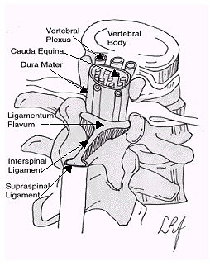
Figure 2. Local spinal anatomy
Tools of the trade
We are almost ready to talk about how to do the lumbar puncture. First, an introduction to the equipment you will be using. The lumbar puncture kit contains: two sterile drapes, three cleaning sponges, a 20 gauge spinal needle, a 25 gauge and a 20 gauge needle for anesthetic infiltration, a 3cc syringe, a vial of 1% lidocaine for anesthesia, a pressure manometer with tubing, four collection vials and a Band-Aid. The other tools you may need include sterile gloves, a facemask, a gown, and proviodine cleaning solution. If you are performing the lumbar puncture with a small atraumatic needle as discussed later, you will need to add to the kit a small gauge Sprotte or Whitacre needle and a regular 18 gauge needle. The kit should look similar to the photograph below:
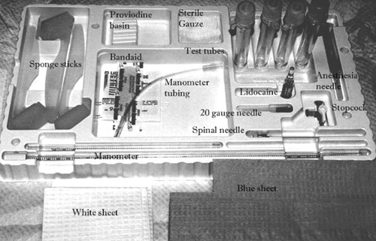
Figure 3. LP tray
The LP sequence
The first part of a successful lumbar puncture is the positioning of your patient. Your patient should lay in the left lateral decubitus position with their back facing you at the edge of the bed. In this position, the patient is encouraged to curl up his shoulders and legs while arching his back "like a cat". This position will maximize the distance between the spinous processes while pulling the spinal cord superiorly (away from the LP site). It is important at this point to ensure that your patient's hips and shoulders are perpendicular to the bed, as rolling of the shoulders or hips will distort your landmarks and decreases the likelihood of a successful lumbar puncture. Hyperflexion of the neck is discouraged as it does not add to the flexion of the back.
Once the patient is in the proper position, feel the posterior superior iliac crests and imagine a line that connects the two. This line will cross the L3-L4 interspace. You may choose this space, or one above or below to use in the adult patient. You may mark this space by pressing the edge of a coin or the plastic hub of an 18 gauge needle into the skin of patient's back at this space. The skin dent in this area will help with landmarking once the patient is under the sterile drape. Once the patient is properly positioned, ensure that you have a stool for sitting and that the bed is raised to a comfortable height for you to do the procedure.
At this point you wish to put on your mask and gown, open your LP tray, and then don your sterile gloves. It is essential to prepare all the equipment on your tray before proceeding. You should not find yourself fumbling for equipment when the spinal needle is in your patient.
Stand the collection tubes in their holders and remove their caps. Draw your local anesthetic into the provided syringe with the 25 gauge needle, and assemble your manometer. Have an assistant place proviodine into the provided compartment in the tray. Once your tray is set, place the white sterile sheet along the bed, slightly under your patient (by keeping the sheet folded over your hands you will not ruin your sterile gloves). Now apply the proviodine solution to your patient's back using the provided sponge brushes. Work in circular strokes starting at the skin dent you placed on the patient's back and working concentrically outward. Do not apply so much proviodine that it runs down the patient's back as this will contaminate the lumbar puncture site. Repeat this two more times with the provided sponge sticks. Once the proviodine is placed, wipe the excess proviodine off, using the same motion with a sterile gauze.
At this point, pick up the blue sterile drape. Remove the adhesive tape cover. Place the drape on the patient so the adhesive tape is oriented towards the patient and will stick to the area of their hips. Align the hole in the drape so that it exposes the area you intend to use for the lumbar puncture. Ensure the top of the blue drape rests over your patient's hips as this drape will allow you to palpate the posterior superior iliac crest (if you need to re-landmark your LP site) as well as access the sterile field during your procedure.
You are now ready to provide the anesthesia for the lumbar puncture. Locate your chosen interspace (L3-L4 if using the posterior superior iliac crest line). Take your anesthetic (with a 25 gauge needle) and locate a point approximately two-thirds of the way down the interspace (i.e. two thirds the distance caudal to the L3 spinous process if using the L3-L4 interspace). Raise a skin bleb with your lidocaine here. Proceed to anesthetize the deeper subcutaneous structures by directing the needle towards the umbilicus. After half of the lidocaine is administered, switch your needle to the 20 gauge, 1 inch needle. Replace the needle in the area previously injected with lidocaine. With this needle, anesthetize the deeper tissues in a fan shaped distribution. This fan shape distribution is needed to anesthetize the recurrent spinal nerves that innervate this area and this will make the procedure much less painful.
After the anesthetic has been placed, it is time to proceed with the actual LP. Take out your spinal needle, and check that the stylet slides easily. When doing the LP with the provided spinal needle, ensure that the notch of the stylet (that bead on the plastic part of the stylet) is facing up to the ceiling. Position the needle at the site of the anesthetic injection (two thirds distally between the two spinous processes). Your needle should be parallel to the bed and directed towards your patient's umbilicus. Grip the proximal portion of the needle in your left hand for control and with your right hand guide the needle while holding the stylet in place. Puncturing the skin may require some force. Following the skin puncture, advance the needle through the subcutaneous tissue and into the supraspinal and intraspinal ligaments. Advance the spinal needle, while continuing to ensure the needle is parallel to the bed and aimed at the umbilicus. Occasionally, while advancing the needle, you will encounter bony resistance. If this should happen, remove your needle to the subcutaneous tissues and direct the needle slightly more cephalad. As you advance the spinal needle deeper through the ligaments repeatedly remove the stylet and check for CSF flow. In most instances as you advance the needle you feel a 'pop'. This accompanies the piercing of the ligamentum flavum and dura mater. This often signifies that you are in place. In sharp cutting needles, you may pass through the ligamentum flavum and dura mater without feeling the "pop". At this point the stylet is removed and CSF should flow freely.
If you are measuring opening pressure, the manometer is attached to the spinal needle and the stopcock opened to allow for CSF to fill the manometer. It is often helpful to have an assistant steady the top portion of the manometer, so you are free to manipulate the stopcock. The opening pressure is taken as the pressure in the column after it ceases to rise. You can expect some respiratory variation (rise and fall of the fluid meniscus with breathing). Normal opening pressures are 5-20 cm H2O in patients with relaxed neck and extended legs, or 10-28 cm H2O in those with flexed legs and back. Following the opening pressure measurement, the stopcock is turned so that the CSF drains out through the spigot and is collected in the four test tubes provided in the LP kit.
If you are not measuring opening pressure, then when CSF flow begins, collect the CSF in the sequentially labeled test tubes (i.e. tube #1 gets CSF first, tube #4 gets CSF last). You need to collect approximately one millilitre of CSF per test tube.
When the necessary CSF has been collected, the stylet is replaced into the spinal needle and the needle is withdrawn in one motion. Clean your patient's back and put the provided Band-Aid onto his/her back. Congratulations, you have just completed the lumbar puncture!
The small atraumatic needle method
As mentioned previously, using smaller, atraumatic needles decreases the incidence of post lumbar puncture headache. If you have chosen to perform this method, you will need to add two pieces of equipment to your LP tray: a small gauge Sprotte or Whitacre needle (I often use a 24 or 27 gauge) and a regular 18 gauge needle (the type you draw up medications with). Add these to you LP tray before beginning your procedure. What you will immediately notice is the small gauge needles are very flexible. This can lead to difficulty in directing the LP needle as it tends to flex and bend while being advanced through the soft tissues. To solve this problem, you will use the 18 gauge needle as a "guide" for the smaller, more flexible LP needle.
Begin the LP as you would normally, with positioning the patient, cleaning the sterile field, draping and anesthetizing the back. Once the patient is anesthetized, take your 18 gauge needle and place it between the two spinous processes as though you were using it as your LP needle (two thirds of the way caudal between the spinous processes, parallel to the bed and aimed at the umbilicus). Insert the needle up to its hub. The 18 gauge needle should feel firmly embedded in the ligaments when properly placed, yet it is too short to reach the spinal canal.
Now take your smaller LP needle and advance it through the 18 gauge needle. This guides the flexible LP needle towards the spinal canal while preventing it from bending. As with the regular LP, remove the stylet often as you advance, checking for CSF flow. You will often feel the 'pop' as you pass through the ligamentum flavum and dura mater signifying that you are in the correct space. Note that CSF flow will be slower due to the smaller needle, thus you will need a little more time for pressure measurement and CSF collection.
What to do with this CSF?
You've now breathed a sigh of relief, and managed to obtain four vials of CSF. Now what? Well, you need to send them to the lab for analysis. The recommended studies include (this order can be changed):
- Tube#1 : Gram stain, Culture and Sensitivity
- Tube#2 : Glucose, Protein
- Tube#3 : Cell Count and Differential
- Tube#4 : Any special studies you require (fungal/viral/chemical studies)
In order to interpret your results, it is important to know about the normal CSF content.
The following table outlines the values seen in a normal LP:
Study | Normal Value | Comment
Opening Pressure | 5-28 cm H₂O
Appearance | Crystal clear | Fluid may appear clear with as many as 400 cells/mm³
Xanthochromia | None
RBC's | 5 per mm³ | May be increased in traumatic tap
WBC's | 5 per mm³ | Exclusively lymphocytes and monocytes
Glucose | 60-70% of serum value or 2.2 - 3.9 mmol/L
Protein | 0.2 - 0.45 g/L | Increased in disease states
Gram Stain and C&S | Negative
Recall that the opening pressure is measured at the start of your LP with the pressure manometer. This pressure is only valid in the lateral decubitus position. Increased opening pressures suggest increased intracranial pressures from a mass lesion (neoplasm, hemorrhage or cerebral edema), overproduction of CSF (choroid plexus papilloma) or a defective outflow mechanism through the ventricles.
Normal CSF is crystal clear in appearance, yet up to 400 cells/mm³ can reside in the CSF and the physician will not see changes in the clarity of the CSF. There are two major reasons for cloudy CSF. The first is the presence of large numbers of WBC's. In CSF infection, the CSF can appear turbid as the number of WBC's increases. They accumulate to the point of making the CSF appear cloudy or it can even appear as pus. The second reason for CSF discoloration is due to red cells and their breakdown products. Large numbers of RBC's in the CSF can make the CSF appear very bloody. After the blood has been in the CSF for greater than 12 hours, the red cells begin to lyse in large quantities and the oxyhemoglobin and bilirubin cause a yellow orange discoloration of the CSF. This orange red discoloration is known as xanthochromia and can be measured in the lab by spectrographic analysis. Formation of the RBC breakdown products peaks about 24 hours after blood enters the CSF and resolves in 3 – 30 days. The presence of xanthochromia is always pathological.
Normal CSF is allowed to have up to 5 RBC's per mm³, albeit it is common to find no RBC's in the CSF. Levels higher than this suggests either SAH, intracranial bleed or traumatic tap. A traumatic tap occurs when the LP needle enters a blood vessel while performing the procedure. Traumatic taps commonly occur when the needle has advanced slightly too far and transfixed the internal vertebral plexus (the more densely packed area of vasculature on the ventral side of the spinal cord). Differentiating between traumatic tap and SAH is usually fairly easy. If you suspect a traumatic tap, order cell counts on test tubes one and three. As the CSF washes the needle, the blood will also be washed out and the number of RBC's should decrease. Also have the lab examine the CSF for xanthochromia. Because the traumatic tap is acute, there should be no xanthochromia. The presence of xanthochromia suggests there has been previous CSF bleeding.
The normal CSF contains up to 5 WBC's per mm³. These may be either lymphocytes or monocytes. If the CSF contains more than 5 WBC's or other cell lines, infection is likely. The most worrisome of these is acute bacterial meningitis. Bacterial meningitis displays a marked pleocytosis ranging between 500 and 20000 WBC/mm³. The differential of these cells demonstrates mostly neutrophils. Meningitis may also be caused by a variety of viruses. The CSF in these cases demonstrates 10 to 1000 WBC's per mm³ with a differential of mostly lymphocytes and monocytes.
CSF glucose is normally 60-70% of the serum values. Glucose enters the CSF by the choroid plexus or through active transport in the capillary membranes. Low levels of glucose are commonly seen in CNS infection and are due to inhibition of the glucose active transport as well as increased utilization of glucose by the brain and spinal cord. Elevated glucose levels are usually inconsequential and suggest serum hyperglycemia.
Causes of CSF Hypoglycemia:
- bacterial meningitis
- tuberculous meningitis
- fungal meningitis
- mumps meningitis
- amebic meningitis
- chemical meningitis
- trichinosis
- syphilis
- herpes encephalitis
- SAH
- meningeal carcinomatosis
- sarcoidosis
- cysticercosis
- hypoglycemia
CSF protein usually runs in the 0.2 – 0.45 g/L range. Most of the proteins are carried in from the blood and delivered to the CSF based on membrane permeability and protein size. Increased protein levels are seen in numerous disease states and especially in meningitis and SAH.
Gram stain is an invaluable tool in suspected bacterial meningitis. Gram negative diplococci are suggestive of N. meningitidis. Small gram negative bacilli may indicate H. influenza. Gram positive cocci are suggestive of S. pneumonia, Streptococcus or Staphylococcus species. Unfortunately, up to 20% of gram stains may be falsely negative as there are not enough organisms to see.
A review of the CSF values in common disorders shows:
Study | Bacterial Meningitis | Viral Meningitis | SAH
Opening Pressure | Often elevated | Often elevated | Often elevated
Appearance | Clear to turbid | Often clear | Clear to bloody
Xanthochromia | Negative | Negative | Often present
RBC's | <5 per mm³ | <5 per mm³ | >50 per mm³
WBC's | Elevated. Many PMNs | Elevated. Many lymphocytes | Slightly increased
Glucose | Low | Normal | Normal
Protein | Elevated | Elevated | Elevated
Gram Stain | May show organisms | Normal | Normal
Equipment Tray
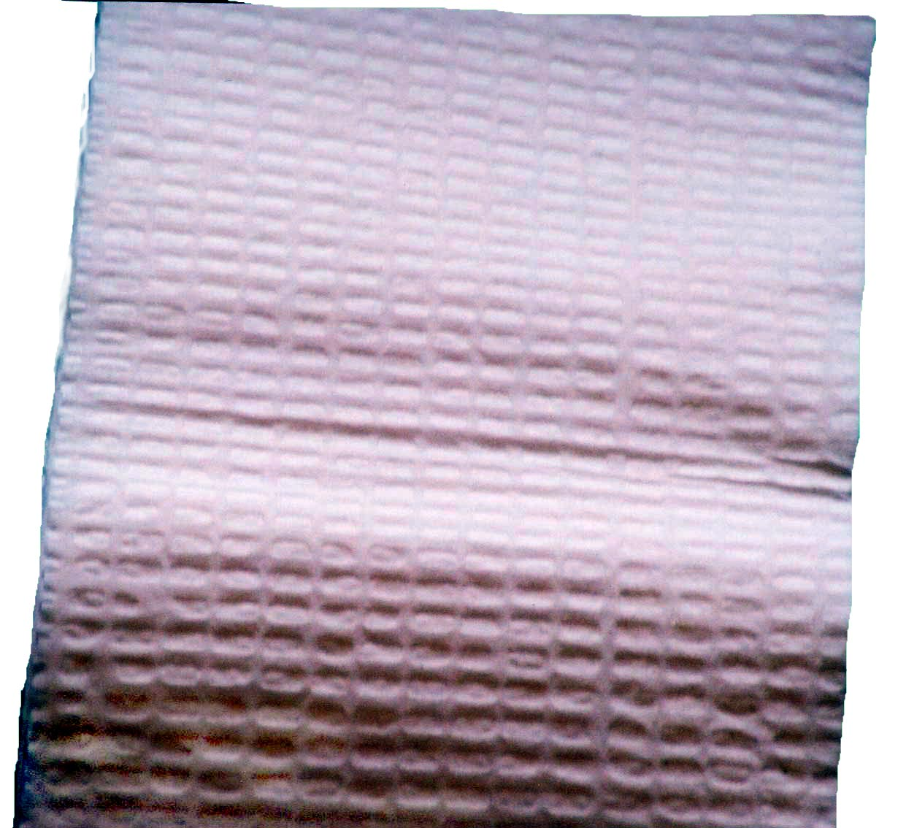 | White sheet  The white sheet is used to provide a sterile surface along the bed, as well as to protect the bed from soiling. It is placed as part of the setup procedure.
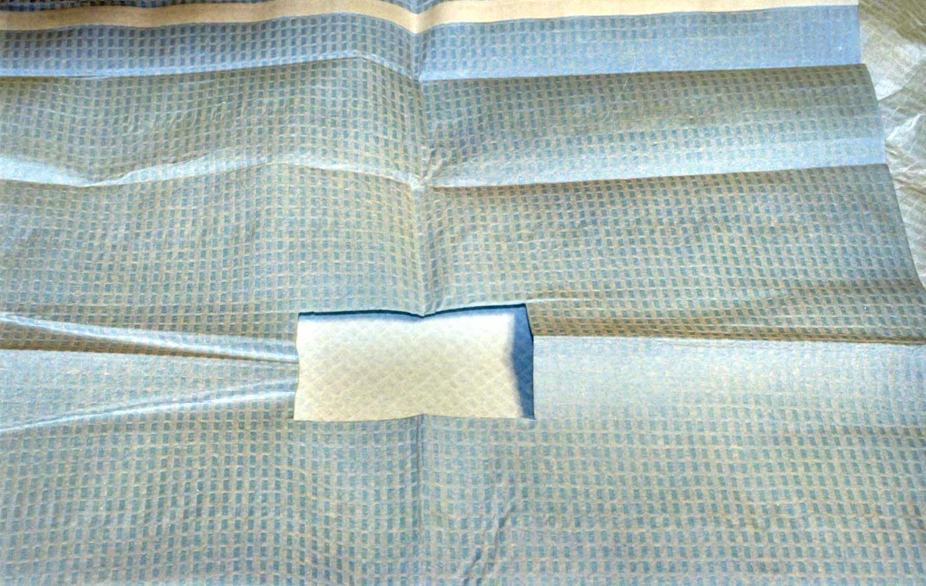 | Blue sheet  The blue sheet is used to provide a sterile field for performing the lumbar puncture. Note that there is an adhesive layer on one side of the sheet. This is exposed and the adhesive is applied to the patient to hold the sheet in place. This sheet has a rectangular opening in the middle through which one performs the lumbar puncture.
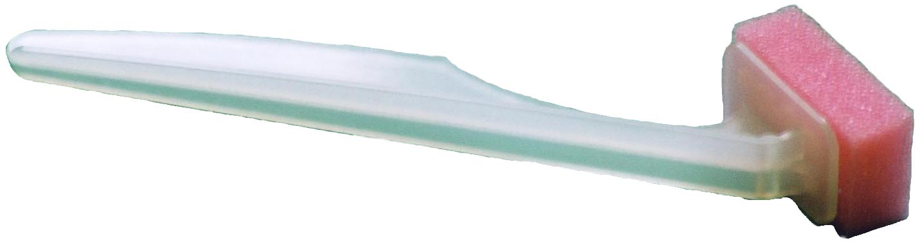 | Sponge sticks  These are used to apply proviodine to the patient's back in order to sterilize the skin as part of the setup procedure.
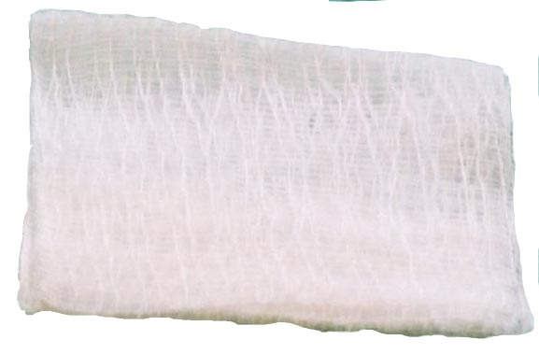 | Gauze  Gauze is used to wipe away excess proviodine from the lumbar puncture site.
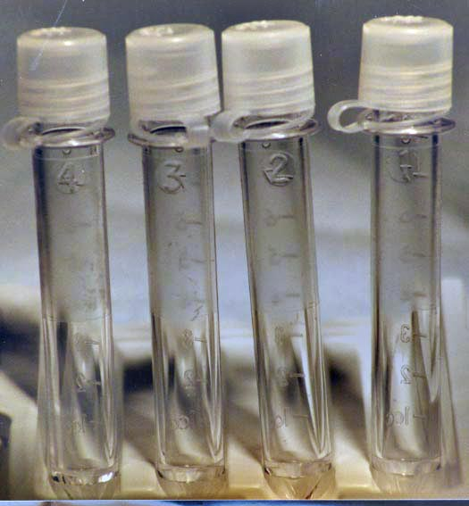 | Test tubes  There are four test tubes provided for the collection of CSF. Note that they are labeled one through four. These should be opened and placed upright when one sets up the tray. One gathers the CSF beginning with tube one and ending with tube four.
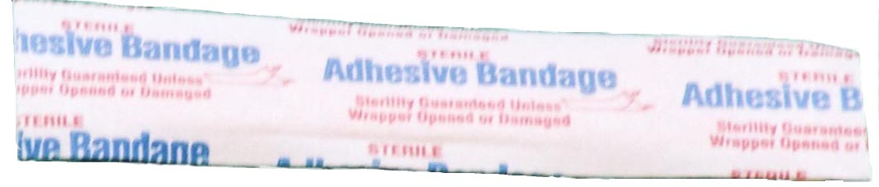 | Bandaid  The bandaid is placed over the lumbar puncture site at the completion of the procedure to prevent mild bleeding from the skin puncture site.
Manometer
The manometer is used to measure the opening pressure of the CSF. It is a set of graded plastic tubes that connect together. The maximum height of the CSF column can then be read off of the side of the manometer. It attaches to the top portion of the stopcock by the flexible manometer tubing. The manometer tubing allows one to connect the manometer to the rear outlet of the stopcock allowing for some more flexible movement of the manometer if desired.
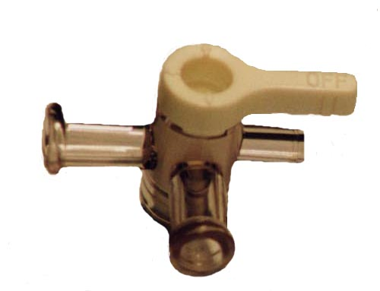 | Stopcock  The stopcock connects the lumbar puncture needle to the manometer (or manometer tubing). It has a lever that controls which of the three openings of the stopcock are open. One connects the lumbar puncture needle to the stopcock and the stopcock to the manometer to measure opening pressures.
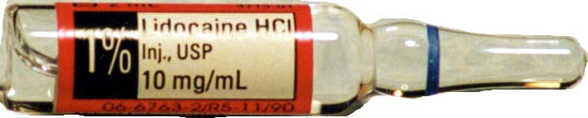 | Lidocaine  The lumbar puncture tray is equipped with 1% lidocaine to use as local anesthetic for the skin and deeper structures.
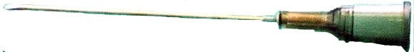 | 20 gauge needle  This needle is used to administer local anesthetic to the deeper structures of the back.
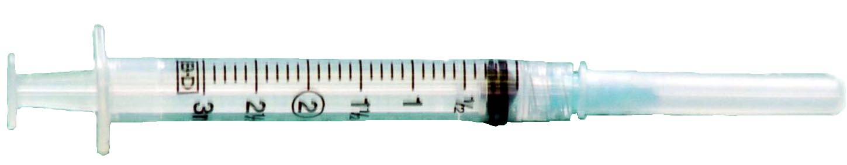 | Syringe and 25 gauge needle  This setup is used to provide local anesthesia to the skin. The 25 gauge needle is removed and the provided 20 gauge needle is placed on the syringe. This is then used to provide local anesthesia to the deeper tissues of the back.
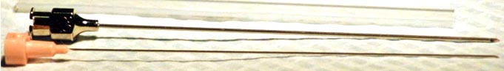 | Spinal needle  The lumbar puncture kit comes with a 20 gauge spinal needle that is used to obtain the CSF. Note that this needle has a removable stylet. The stylet should be in place anytime the lumbar puncture needle is advanced or removed. The needles in this tray are the Quincke type and have a sharp cutting tip.
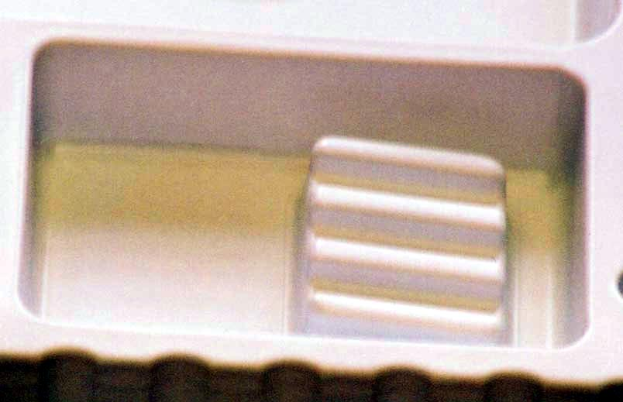 | Proviodine tray  This tray holds the proviodine (which must be added to your tray separately). One dips the sponge stick into the proviodine and then presses the sponge into the raised ridges, expelling the excess proviodine.
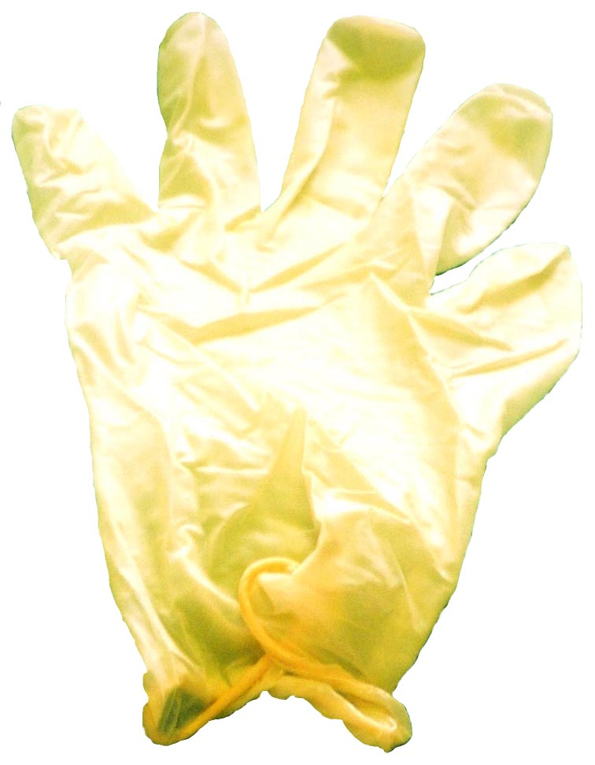 | Gloves  Standard sterile gloves must be used for handling sterile equipment and in performing the lumbar puncture.
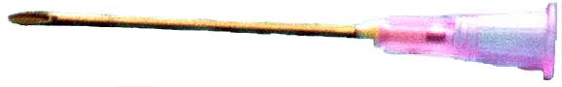 | 18 gauge needle  This needle is used to mark the site of the lumbar puncture. By pressing the blunt en of the needle into the patient's back, a small circular mark is left on the skin. This mark is used to help in finding your lumbar puncture site once the site is prepped and draped.
Step 1: Positioning
One of the most vital steps in the lumbar puncture is positioning your patient. Raise the bed to a comfortable height for you. Lie the patient on their side and bring their back to the edge of the bed. Instruct your patient to curl into the fetal position, arching their lower back. At this point it is imperative that your patient's shoulders and hips are perpendicular to the bed. This will ensure the spinal anatomy is aligned for an easy lumbar puncture.
Step 2: Landmark the LP site
With your patient in the correct position, feel for the posterior superior iliac crests. An imaginary line between these two crests crosses the L3-L4 interspace. Locate this interspace by palpating the spinous processes of L3 and L4. It is acceptable to use L3-L4 or an interspace above or below for the LP.
Step 3: Marking the LP site
In order to mark your LP site, press the blunt end of an 18 gauge needle into the skin of your patient's back at the interspace you have chosen for the procedure. Make this mark in the distal two-thirds of the interspace as this is where you wish to place your needle. This skin mark will still be visible after you prep the skin.
Step 4: Tray Opening
At this point you will need to open your tray. Peel the paper covering away from your LP tray being careful not to contaminate the sterile inner tray. Now put on your sterile gloves.
Step 5: Opening the inner tray and tray setup
While wearing your sterile gloves, open the inner wrap of the LP tray. Take care not to contaminate your gloves while doing this. Once the tray is open, set up the tray for use. Assemble the manometer, manometer tubing (if you use this) and stopcock together. Stand the test tubes up in the tray and remove their caps. Note they are numbered 1 through 4. Open the lidocaine bottle and draw the lidocaine into your 25 gauge needle and syringe for anesthesia. Finally, have an assistant place proviodine into the proviodine basin.
Step 6: Prep and drape
Place your white sterile sheet slightly under your patient, taking care to remain sterile. Remove one of the sponge sticks and soak the sponge end in the proviodine. Squeeze the excess out on the grate provided in the proviodine basin. Use the proviodine to clean the skin around the LP puncture site. Begin at the site of your LP and clean in overlapping and gradually widening circles. Ensure you are cleaning enough skin so that the area you will be working in is completely sterile. Discard the sponge stick when this is finished. Repeat this twice. Now take your sterile blue sheet and remove the sticky tab from the back of it. Using the sticky portion of the sheet to secure it to your patient, place the sheet over your patient's hip. Your LP site should now be exposed through the middle opening of the sheet.
Step 7: Cutaneous anesthesia
Using the provided 25 gauge needle, begin to freeze the skin at the site marked for lumbar puncture. Place the needle two-thirds of the way towards the chosen lower spinous process. Start your injection of lidocaine just prior to insertion of the needlen into the skin and administer the lidocaine slowly to minimize the pain of the injection. Raise a skin bleb. Then position the needle parallel to the bed and aim it towards the umbilicus. Advance the needle while administering the lidocaine. Continue this until the needle is completely inserted using about half of the provided lidocaine.
Step 8: Deep anesthesia
Replace the 25 gauge needle with a 22 gauge needle on the lidocaine syringe. Position the needle as previously: parallel to the bed and aiming towards the umbilicus. Insert the needle into the deeper tissues of the back while injecting lidocaine. Remember to apply suction to the needle prior to injection to prevent intravascular injections. As you get deeper, you may provide a vertical "fan" shape area of injection to help anesthetize the recurrent spinal nerves. Withdraw the needle as you are finishing, injecting lidocaine on the way out.
Step 9: Lumbar puncture
Obtain your lumbar puncture needle. Check that the stylet slides easily out of the needle prior to use. If using a beveled needle, ensure it is oriented correctly (the notch on your stylet should point towards the ceiling). Now recheck your lumbar puncture site by palpating the posterior superior iliac crest and ensuring you are in a correct spinal interspace. Position the needle in the same way you did for the anesthesia. It should be placed two thirds of the way towards the distal spinous process. Ensure the needle is parallel to the bed and aimed at the umbilicus. Advance the needle. A 'pop' will often signal the puncture of the ligamentum flavum and dura. When this occurs, replace the stylet and advance the needle slowly while repeatedly removing the stylet and checking for CSF flow.
Step 10: Attach the manometer
Once you have established CSF flow, attach the stopcock and manometer to the lumbar puncture needle. The arm of the stopcock should be in the down position. It is very helpful at this point to have an assistant hold the top portion of the manometer for you. When attached, ensure that the connecting tube between the stopcock and the manometer is at the same level of the LP needle. This avoids falsely elevating or lowering the pressure reading. At this point, ask your patient to relax their legs and slowly straighten them.
Step 11: Obtain opening pressure
At this point, the CSF should flow past the stopcock and up the manometer tubing. Again, ensure that the connecting tube is level with the stopcock. Watch the CSF flow up the manometer. When the CSF column reaches its peak you will notice a slight up and down variation with respiration. This is the opening pressure. Normal opening pressures are 5-20 cm H₂O with a relaxed back and legs. This pressure may be as high as 28 cm H₂O if the patient is left curled up.
Step 12: Collecting the CSF
From your tray, get your first test tube (labeled #1 on the tube). Place this under the outflow tract of the stopcock. Turn the stopcock towards the patient's back. This will open the manometer to the outflow tract and drain the manometer's contents into the test tube. Then turn the stopcock towards the manometer. This opens the outflow tract to the LP needle and CSF should drip into the test tube. Once one milliliter of CSF is collected, replace test tube 1 with test tube 2 and continue to collect one milliliter of fluid per test tube for the remaining tubes.
Step 13: Finishing up
When the CSF has been collected, detach the manometer from the LP needle. Replace the stylet into the LP needle and remove the needle. Now remove your sterile drapes, clean the area and place a bandage on the LP site. Congratulations, you are done!
Self-assessment questions
Question 1
The imaginary line connecting the posterior superior iliac crests crosses what spinal interspace?

 | L1-L2
 | L2-L3
 | L3-L4
 | L4-L5
 | L5-S1

Question 2
Which of the following patients does not need a CT-scan prior to lumbar puncture?

A well patient with new onset right arm weakness
A known cancer patient with headache and new onset right arm weakness
An acute trauma patient with headache and bilateral leg weakness
A twelve year old boy with normal exam but fever and nuchal rigidity

Question 3
If bony resistance is encountered while performing a lumbar puncture, bring the spinal needle back to the skin and direct it more towards the:

Right
Feet
Parallel plane of the back
Head

Credits
Congratulations!
You have now completed the Lumbar Puncture module.
Credits
- This web-based module was developed by Adam Szulewski based on content written by Dr. Bob McGraw and Dr. Ian Rigby for the Queen's University Department of Emergency Medicine Summer Seminar Series and Technical Skills Program.
- The module was created using exe : eLearning XHTML editor with support from Amy Allcock and the Queen's University School of Medicine MedTech Unit.
License
This module is licensed under the Creative Commons Attribution Non-Commercial No Derivatives license. The module may be redistributed and used provided that credit is given to the author and it is used for non-commercial purposes only. The contents of this presentation cannot be changed or used individually. For more information on the Creative Commons license model and the specific terms of this license, please visit creativecommons.ca.

