Basic Suturing and Wound Management
A Self-Directed Learning Module
Technical Skills Program
Queen’s University
Department of Emergency Medicine
Introduction
The purpose of this tutorial, which includes this online module and a suturing seminar, is to introduce students to the basics of wound management and allow them to practice simple suturing on a prosthetic model. Basic suturing is an essential psychomotor skill in the everyday practice of medicine. Although suturing technique is important, the physician must also have a thorough understanding of wound management in general to effectively care for a patient with a laceration. Students should complete this module and complete the embedded multiple-choice questions prior to their scheduled suturing seminar. There will be a brief multiple-choice exam based on this material at the beginning of the seminar.
Objectives
On completion of this module, students will:
- Understand the principles of wound management as they apply to a simple laceration.
- Be able to demonstrate the preparation of a simple laceration for closure.
- Be able to demonstrate sterile technique while preparing and suturing a simple laceration on a model.
- Be able to demonstrate basic suturing techniques on a model.

Wound considerations
Each wound that is encountered and considered for repair must be addressed independently. Factors such as location, size, mechanism of injury, time elapsed since injury, likelihood of contamination and patient dependent factors must be addressed prior to formal treatment. As well, the physician or student should consider whether or not they have the skill or experience to adequately manage a particular wound.
Wound location is important. Lacerations on the face, hands and perineum, for example, are more complicated for cosmetic structural reasons. These areas should be reserved for more experienced physicians. Lacerations of the scalp, trunk and proximal extremities tend to be less complex so more appropriate for beginners. As with all forms of medical care, it is important to be aware of one's own abilities and limitations and to request assistance, if necessary.
A functional assessment of nerves, blood vessels, muscles and tendons is essential early in the evaluation of the wound. It must be done prior to injection of local anaesthesia, as this will obviously interfere with the assessment.
Knowledge of the mechanism of injury can provide valuable insight into the potential for injury to adjacent structures, the likelihood of contamination and the preferred method of repair. Deep puncture wounds can injure blood vessels and nerves, and contaminate several tissue planes. They are probably best left open after thorough cleansing, as there is a high risk of subsequent infection if sutured primarily. Conversely, a superficial laceration from clean glass may be cleaned and either sutured or taped to approximate the edges.
Lacerations resulting from significant blunt force often require debridement and revision of wound edges to optimize healing. As well, the edema and inflammatory response resulting from blunt injury can adversely affect the already tenuous blood supply to the area.
All traumatic wounds must be assumed to have some degree of contamination by virtue of the presence of dirt, microorganisms and devitalized tissue. An infected wound will not heal properly due to adverse effects on tissue regeneration.
The time elapsed from injury to repair has a direct bearing on the subsequent risk of wound infection. Any wound that has been exposed for greater than 8 hours is at significant risk for infection, regardless of the mechanism of injury.
Wounds that are more than 8 hours old and grossly contaminated wounds, such as animal bites and farming injuries, are at such high risk for subsequent infection that consideration should be given to leaving them open. Initial management should focus on thorough cleaning and close monitoring for infection. Suturing a grossly contaminated wound, which greatly increases the risk of infection, should always be balanced against the benefits of faster healing and better cosmetics.
Patient dependent factors known to negatively influence the process of wound healing include advanced age, poor nutritional status and co-existing illness such as diabetes. These factors can lead to delayed healing, dehiscence, abnormal scarring and infection and must be considered when instructing the patient regarding follow-up.

Categories of wound closure
Closure by primary intent:
This refers to wound closure immediately following the injury and prior to the formation of granulation tissue. In general, closure by primary intent will lead to faster healing and the best cosmetic result. Most patients presenting within 8 hours of injury can have the wound closed by primary intent. Simple and clean facial wounds, by virtue of the rich vascular supply to the face and the need for a good cosmetic result, can be closed by primary intent as late as 24 hours after the injury.
Closure by secondary intent:
This refers to the strategy of allowing wounds to heal on their own without surgical closure. Of course the wound should be cleaned and dressed as with any wound. Certain wounds such as small partial thickness avulsions and fingertip amputations are best left to close by secondary intent.
Closure by tertiary intent:
This refers to the approach of having the patient return in 3-4 days, after initial wound cleansing and dressing, for wound closure. This is also referred to as delayed primary closure. Closure by tertiary intent is used for patients with wounds who present late (>24 hours) for care, contaminated crush wounds and mammalian bites when leaving the wound open would result in an unacceptable cosmetic result.
Wound antisepsis and sterile technique
Unquestionably, efforts taken to properly prepare the wound and the surrounding skin surfaces will influence the likelihood of infection and will directly impact on the process of wound repair. Under normal circumstances, the skin surface surrounding a wound about to be sutured should be washed and disinfected with a solution that is rapidly acting, with a broad spectrum of antimicrobial activity.
Prior to cleansing, the area around a wound may have to be anaesthetized to reduce the discomfort to the patient.
Most Emergency Departments will stock a range of antiseptic solutions, including 1% Profidone Iodine (Proviodine), Hydrogen Peroxide and Chlorhexidine-based solutions (Savlodil, Savlon). Although excellent skin cleansers, these solutions are potentially toxic to the local wound defenses and may increase the rate of subsequent wound infection if they are spilled into a wound in large quantities. These solutions should be irrigated from the wound with a sterile normal saline solution as the final step in wound cleansing.
It is rarely necessary to remove significant quantities of body hair prior to repair of a simple laceration. In fact, razor removal of hair has been shown to damage surface skin follicles and lead to increased rates of wound infection. Occasionally, for repair of scalp lacerations, for example, scissor trimming will allow for easier identification of wound margins and will facilitate later wound care. Due to inconsistent regrowth of eyebrow hair, it should never be shaved when repairing lacerations in that area.
Actual preparation of the wound involves cleansing and debridement. The ideal wound cleanser should have broad antimicrobial activity, but should not delay healing or reduce tissue resistance to infection. There is controversy about the potentially adverse effects of the readily available skin cleansing antiseptic solutions when introduced directly into the wound. What is certain, however, is that 0.9% normal saline is a very effective and non-toxic irrigating solution. Therefore, 0.9% normal saline should be used as the final solution when cleaning a wound and one should minimize spillage of other solutions into the wound during preparation.
Wound irrigation is a form of mechanical wound cleansing that is known to effectively remove bacteria and other debris. A 10 c.c. or 20 c.c. syringe can be fitted with a commercially available splash cover, and the wound can then be irrigated with either normal saline or Ringer's lactate. These solutions are used because they do not irritate body tissues. Following irrigation, remaining debris and devitalized tissue can be removed with fine forceps or with a scalpel.
Ensuring sterile technique while repairing a wound is, perhaps, the most difficult concept for the inexperienced person to grasp. A break in sterile technique, with contamination of the field, is a common procedural error. It leads to an increased incidence of wound infection and breakdown.
Sterile technique requires that the physician:
- is able to open and don gloves without contamination to the sterile surface of the gloves
- is able to clean and drape the wound and surrounding area
- is able to control the instruments and suture, such that they are not contaminated by non-sterile surfaces
Local Anaesthetics
For any patient about to be sutured, attention must be given to obtaining adequate analgesia and ensuring overall comfort. After documenting the neurovascular status of adjacent structures, which must be done in every case, a local anaesthetic can be injected into the tissue in and around the wound. A 1% solution (10 mg/cc) of lidocaine can be used for most wounds.
Lidocaine 1% is very safe when used in the small quantities usually required for simple lacerations. The physician should not use in excess of 3mg/kg of lidocaine. Its onset of action when infiltrated locally is within seconds and its duration of action is generally 30 to 60 minutes. Lidocaine is also available in 0.5% (5 mg/cc) and 2.0% (20 mg/cc). The 0.5% is useful in pediatric patients, whereas the 2.0% solution is rarely necessary.
Epinephrine is added to some of the commercially available lidocaine solutions. It is a potent vasoconstrictor and functions to prolong anaesthesia by slowing vascular uptake of the lidocaine, and to reduce the bleeding into the wound, which can impair visualization of structures. Solutions containing epinephrine are best avoided by inexperienced physicians as there are risks associated with their use.
Lidocaine causes an intense burning sensation when injected locally. The burning is dependent on the rate of injection and the acidity of the solution. The burning can be minimized by slow injection using a small gauge needle (#25, #27, or #30). An experienced physician can inject local anaesthetic with virtually no discomfort if time and care are taken.
Recently, it has been shown that the addition of bicarbonate to buffer the lidocaine solution can reduce some of the burning sensation at the injection site. However, this buffered solution is not available commercially and must be made up in the Emergency Department as it has a short shelf life.
Suture Materials
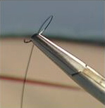
There are a number of suture materials available, but it is beyond the scope of this module to cover them in any detail. In selecting a particular suture, the physician needs to consider the physical and biological characteristics of the material in relation to the healing process.
Suture materials can be broadly categorized as absorbable and non-absorbable. Absorbable sutures do not require removal as they are digested by tissue enzymes. Non-absorbable or permanent sutures need to be removed at a later date.
Absorbable sutures can be further divided into rapidly absorbing (days) and slowly absorbing (months). The choice will depend on the rate at which the particular tissue regains its strength. Fortunately, the choice is often not an issue in the Emergency Department because most wounds encountered there require support for a matter of days to weeks. Sutures available in the Emergency Department will meet this requirement.
Both absorbable and non-absorbable sutures are graded for size or diameter of the strand. The grading system uses the letter O and the number of stated O's indicates the size. The more O's, the smaller the size. For example, a 6-O is smaller than a 4-O. Accordingly, tensile strength of a particular suture type increases as the number of O's decreases.
The needles supplied with sutures also have important features. In general, for Emergency Department use, needles are either large or small and either cutting or non-cutting. Large needles have the advantage of closing a deeper layer of tissue with each "bite". The concern with small needles is that there will be inadequate closure of deep subcutaneous tissues, leaving potential space for hematoma formation. However, small needles create smaller puncture wounds and may have the advantage of reducing scarring
Cutting needles have at least two opposing cutting edges to facilitate passage through tough tissue. These needles are used for skin closure. Non-cutting or tapered needles are used to close subcutaneous tissue, muscle and fascia. They have sharp points, but do not have cutting edges.
Tetanus prophylaxis
Tetanus is a serious disease characterized by muscle spasm and rigidity. The mortality rate is approximately 20% and is due to spasm of the muscles of respiration. Tetanus is an illness preventable through primary immunization and regular booster shots.
The Emergency Department patient encounter provides an ideal opportunity to screen for adequate tetanus immunization and to provide it, when necessary. In North America, the vast majority of people seen in the Emergency Department will have received primary immunization. Groups that may have missed primary immunization include elderly patients and immigrants.
Primary immunization involves a series of four toxoid injections for preschool children or three toxoid injections if started at age 7 or older. Following primary immunization, children receive a booster shot at age 5 and additional boosters every 10 years subsequent to that.
Patients seen in the Emergency Department with clean, minor wounds are considered adequately immunized if they have received primary immunization and have had a booster within the past 10 years. If a wound is "dirty" (which includes wounds contaminated with saliva, feces or dirt, and burn injuries) then a booster within the past 5 years is necessary to ensure immunization.
If the patient has not received primary immunization, (or if the patient is unsure) then passive immunity with tetanus immune globulin (T.I.G.) is provided. At the same time, but with a different injection site, tetanus and diphtheria toxoid should be given. This initiates primary immunization but adequate follow-up should be arranged to ensure completion of the series. Note that the diphtheria toxoid is added to ensure adequate immunity to diphtheria in the population.
Patients will occasionally present stating they have an allergy to the toxoid. Adverse reactions such as local pain, erythemia, fever, malaise or rash are common but should not preclude further immunization. A true anaphylactic or serious neurologic reaction to the toxoid are the only contraindications to further immunization with the tetanus and diphtheria toxoid.
If a patient has had a true serious reaction in the past, they should receive a T.I.G. in the Emergency Department and then follow-up with an allergist to assess immunization status. The table below summarizes the CDC guidelines for tetanus prophylaxis.
Tetanus Immunization:
For clean, minor wounds:
 | Give patient Tetanus Diphtheria Toxoid? | Give patient Tetanus Immune Globulin?
Unknown or less than 3 doses of absorbed Tetanus Toxoid | Yes | No
Greater than 3 doses of of absorbed Tetanus Toxoid | No (unless >10 years since last booster) | No

For all other wounds:
 | Give patient Tetanus Diphtheria Toxoid? | Give patient Tetanus Immune Globulin?
Unknown or less than 3 doses of absorbed Tetanus Toxoid | Yes | Yes
Greater than 3 doses of of absorbed Tetanus Toxoid | No (unless >5 years since last booster) | No
Wound dressing
Dressings are applied after suturing for several reasons. They shield the wound from gross contamination, which is more or less important depending on the patient's occupation. As well, a dressing can absorb blood and serous material oozing from the wound, which serves to protect clothing and bed linen. Finally, a dressing can improve patient comfort by immobilizing injured tissue and avoiding further injury.
Although dressings can prevent gross contamination, it has been shown that wounds which remain covered for periods of greater than 48 hours without an inspection or change are more likely to become infected than wounds left open. After suturing a simple laceration, the patient should be instructed to change the dressing at 48 hours.
Dressing material should be clean, but does not necessarily have to be sterile. Most wounds are covered with a simple, light dressing prior to discharging the patient. If a layered dressing is required for the purpose of greater absorption or application of pressure or splinting, then the first layer should be a non-adherent material such as Vaseline gauze.
Subsequent layers can include absorptive gauze and a pressure pad, if desired.
The final layer should be a Kling™ wrap or elastic bandage to secure the dressing and apply pressure as needed.
Bulky pressure dressings serve to reduce wound drainage and deter hematoma formation, which can increase the potential for infection. As well, they can improve patient comfort by splinting the wound and by supporting the surrounding tissues and may reduce the risk of dehiscence.
Wet dressings should be changed immediately and dirty dressings should be changed as often as 12-24 hours.
Many patients will ask when they can get the sutured wound wet. A clean minor wound can be immersed for brief periods after 48 hours. This allows them to bathe, shower and even swim. The patient should be cautioned against prolonged immersion, as this tends to break down the wound.
Instructing the patient
Patients leaving the Emergency Department after wound management and suturing need a specific set of instructions for ongoing wound care and routine follow-up. As well, they need to be cautioned about possible complications.
Wound care will vary, but in general patients should be told to keep the area clean and dry. The wound may be gently cleaned with plain water or diluted hydrogen peroxide to remove crusting and debris. Dressings that have become wet or dirty should be changed.
If there is significant swelling associated with the wound, elevation of the affected area will improve patient comfort. In areas under stress, such as over joints, splinting for a few days can improve comfort and aid in healing.
Instructions for suture removal need to be given in each case. The length of time sutures are left in depends on the amount of tension in the tissues in the area of the wound, balanced against the fact that sutures will cause additional scarring when left in too long.
The following guidelines for suture removal are generally accepted:
Face | 4-5 days. Replace with Steri-stripsTM
Scalp and trunk | 7-10 days
Arms and legs | 10-14 days
Joints | 14 days
The most common and important complication for patients to be aware of is infection. Signs and symptoms of infection include increased pain, swelling, redness, fever or red streaks spreading proximally. Patients should be cautioned about the potential for infection and encouraged to return to the Emergency Department if any signs of infection are noted.
The suture tray
The basic emergency department suture tray has the equipment necessary to manage a simple laceration.

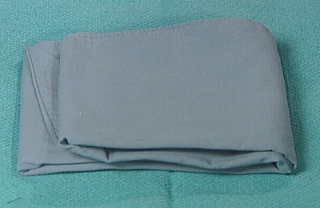 | Surgical Drapes  The surgical drapes should be used to completely surround the wound and a portion of the surrounding sterile field.
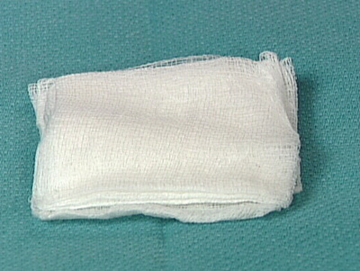 | 4" x 4" Gauze  The gauze is used to clean the wound area.
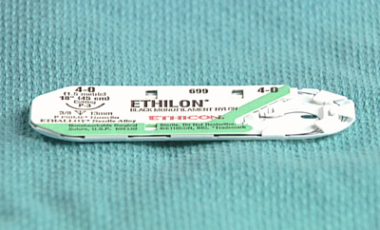 | Suture Materials - 4.0 and 6.0  For facial wounds, a smaller gauge suture such as 6.0 is used. For wounds under greater stress and of less cosmetic importance such as a thigh laceration, a 4.0 suture would be appropriate.
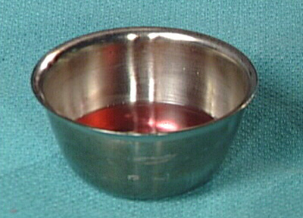 | Antiseptic Solution and Saline  The antiseptic solution is for cleansing the skin around the wound and saline is used to cleanse and irrigate the wound itself.
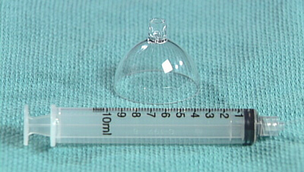 | Syringe with splash cover  Wound irrigation has been shown to be the most effective means of removing debris and contaminants. The splash cover helps to avoid exposure to the patient's blood and body fluids.
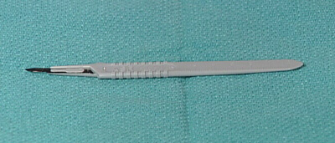 | Scalpel  The operator may request a scalpel to allow a wound to be extended or wound edges to be debrided.
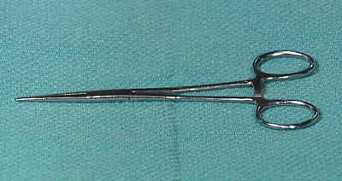 | Straight Hemostat  The straight hemostat can be used for blunt dissection. It should not be used to clamp blood vessels or tissues since it will injure these structures.
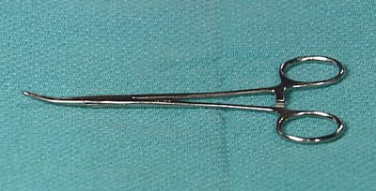 | Curved Hemostat  The curved hemostat can be used for blunt dissection. It should not be used to clamp blood vessels or tissues since it will injure these structures.
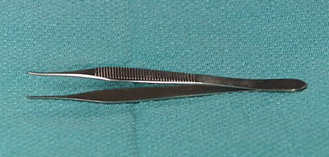 | Toothed Forceps  The toothed forceps are used to grasp the skin edges while suturing. They tend to be less traumatic than non-toothed forceps but can damage tissues if applied forcefully.
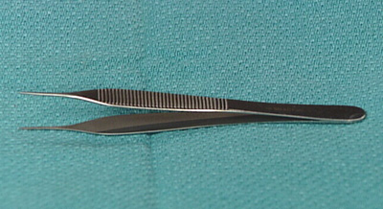 | Non-toothed Forceps  This is considered to be a more traumatic instrument than its toothed counterpart for grasping tissue.
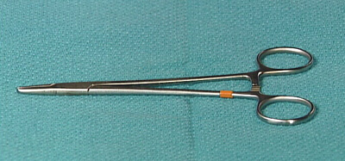 | Needle Driver  The needle driver is reinforced instrument designed to grasp the suture needle.
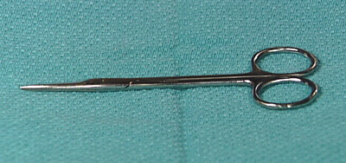 | Scissors  The scissors are intended only to cut sutures. They have no rule in the dissection or removal of tissue.
Step 1: History and physical examination
Each wound that is encountered must be addressed independently. Factors such as location, size, mechanism of injury, time elapsed since injury, likelihood of contamination and patient dependent factors must be addressed prior to formal treatment.
Mechanism of injury: provides insight into potential injury to adjacent structures, likelihood of contamination and preferred method of repair. Laceration resulting from blunt force often require debridement and revision of wound edges to optimize healing.
Time elapsed from injury to repair: any wound that has been exposed for greater than 8 hours is at significant risk for infection, regardless of the mechanism of injury. Grossly contaminated wounds such as animal bites and farm injuries are at such great risk for infection that they are best left open.
Patient dependent factors: includes advanced age, poor nutritional status and coexisting illnesses such as diabetes which can lead to delayed healing, abnormal scarring and infection and must be considered when instructing the patient regarding follow-up.
A functional assessment of nerves, blood vessels, muscles and tendons is essential and must be done prior to injection of local anesthesia as this will obviously interfere with the assessment.
As with all medical care, it is imprtant to be aware of one's own abilities and limitations and to request assistance if necessary.
Step 2: Use of non-sterile gloves
Exploration of any open wound should be done with universal precautions in mind. As such, it is necessary for the student or physician to use non-sterile gloves during the initial physical examination and when injecting local anesthesia.

Step 3: Drawing local anesthetic
Step 4: Injecting local anesthetic
Step 5: Donning sterile gloves
Step 6: Clean and irrigate wound
Step 7: Draping
Step 8: Simple interrupted suture
Step 9: Vertical mattress suture
Step 10: Disposing of sharps
In the interest of safety, the student or physician must personally ensure that all sharps have been disposed of in the yellow sharps container immediately upon completion. This includes needles, scalpels and scalpel blades.
Step 11: Instrucing the patient
Wound care will vary, but in general, patients should be told to keep the area clean and dry. The wound may be gently cleaned with plain water and dressings that have become wet or dirty should be changed. If there is significant swelling, elevation of the affected area will improve patient comfort.
Instructions for suture removal need to be given in each case. The following guidelines for suture removal are generally accepted:
- Face: 4-5 days
- Scalp and trunk: 7-10 days
- Arms and legs: 10-14 days
- Joints: 14 days
The most common and important complication for patients to be aware of is infection. Signs and symptoms of infection include increased pain, swelling, redness, fever or red streaks spreading proximally. Patients should be cautioned about the potential for infection and encouraged to return if any signs of infection are noted.

Step 12: Suture removal
Knot tying
An important part of correct suturing technique is correct method in knot tying. The knots demonstrated here are those most frequently used by physicians. For clarity, one half of the strand is yellow and the other is white. The yellow strand is initially held in the left hand. Both knots demonstrated here are square knots which resist slipping of completed properly. Incorrect technique can result in a granny knot that easily slips when tension is applied. When the two ends of a suture are pulled in opposite directions with uniform rate and tension, the knot may be tied more securely.
One hand technique: | Two hand technique:
Self-assessment questions
Question 1
Which of the following is true regarding animal bites and farming injuries?

 | They should be treated the same as any other injury.
 | They always require extensive debridement.
 | They are at high risk for infection, so require careful cleaning and irrigation and may be best managed by not suturing.
 | They are best sutured and treated with antibiotics.

Question 2:
Which of the following is true regarding toothed forceps?

They are considered more traumatic to the tissues than non-toothed forceps.
They are considered less traumatic to the tissues than non-toothed forceps.
They can substitute as a needle driver if necessary.
They should not be used in management of simple lacerations.

Question 3
Groups at risk for inadequate primary immunization against tetanus include which of the following?

School-aged children
Elderly patients and immigrants
Alcoholics
Pregnant females

Question 4
Which of the following is true regarding sutures?

a 6-O is stronger than a 4-O
a 6-O is larger than a 4-O
a 4-O is stronger than a 6-O
a 4-O is smaller than a 6-O

Credits
Congratulations!
You have now completed the Basic Suturing and Wound Management module.
Credits
- This web-based module was developed by Adam Szulewski based on content written by Dr. Bob McGraw, Jaelyn Caudle, Jordan Chenkin, and Kari Sampsel for the Queen's University Department of Emergency Medicine Summer Seminar Series and Technical Skills Program.
- The module was created using exe : eLearning XHTML editor with support from Amy Allcock and the Queen's University School of Medicine MedTech Unit.
License
This module is licensed under the Creative Commons Attribution Non-Commercial No Derivatives license. The module may be redistributed and used provided that credit is given to the author and it is used for non-commercial purposes only. The contents of this presentation cannot be changed or used individually. For more information on the Creative Commons license model and the specific terms of this license, please visit creativecommons.ca.

